# Getting Ready: The Amazon Online Shopping System

Understand the Amazon problem and learn the questions to further simplify this problem.

**We'll cover the following**

* [Problem definition](https://www.educative.io/courses/grokking-the-low-level-design-interview-using-ood-principles/getting-ready-the-amazon-online-shopping-system#Problem-definition)
* [Expectations from the interviewee](https://www.educative.io/courses/grokking-the-low-level-design-interview-using-ood-principles/getting-ready-the-amazon-online-shopping-system#Expectations-from-the-interviewee)
  + [Discoverability](https://www.educative.io/courses/grokking-the-low-level-design-interview-using-ood-principles/getting-ready-the-amazon-online-shopping-system#Discoverability)
  + [Cart and checkout](https://www.educative.io/courses/grokking-the-low-level-design-interview-using-ood-principles/getting-ready-the-amazon-online-shopping-system#Cart-and-checkout)
  + [Payment methods](https://www.educative.io/courses/grokking-the-low-level-design-interview-using-ood-principles/getting-ready-the-amazon-online-shopping-system#Payment-methods)
  + [Product reviews and ratings](https://www.educative.io/courses/grokking-the-low-level-design-interview-using-ood-principles/getting-ready-the-amazon-online-shopping-system#Product-reviews-and-ratings)
* [Design approach](https://www.educative.io/courses/grokking-the-low-level-design-interview-using-ood-principles/getting-ready-the-amazon-online-shopping-system#Design-approach)
* [Design pattern](https://www.educative.io/courses/grokking-the-low-level-design-interview-using-ood-principles/getting-ready-the-amazon-online-shopping-system#Design-pattern)

## Problem definition

**Amazon** is an online retail platform that allows its users to buy from and sell products to other users in the system. There are numerous product categories that customers can search and choose from. Products have reviews and ratings that can help customers make a buying decision. Each customer has a shopping cart where they can add products they wish to order. Once customers have added their favorite products to the cart, they can check out the cart and choose a payment method to place their orders. The customers are notified about their order and shipment statuses until the order is delivered. The system also allows users to add products they want to sell.

Users interacting with an online shopping system

## Expectations from the interviewee

Numerous components are present in the Amazon online shopping system, each with specific constraints and requirements placed on them. The following provides an overview of some of the main things that the interviewer will want to hear you discuss in more detail during the interview.

### Discoverability

For an online shopping system like Amazon, discoverability is one of the key features that distinguish it from others. You can ask the following questions to know more about the system:

* How will the buyer discover a product?
* How will the search surface result?

### Cart and checkout

One of the most significant attributes of the online shopping system is the cart and checkout functionality that it provides to its customers. The interviewer expects the cart and checkout to behave in a certain way. You may ask the interviewer:

* How will the design adhere to such known best practices while also introducing innovative checkout semantics like “one-click purchase?”

### Payment methods

The interviewer expects you to ask questions about the payment methods to figure out the necessary requirements. You may ask the following questions:

* How will the users pay? Will they use credit cards, gift cards, and so on?
* How will the payment method work with the checkout process?

### Product reviews and ratings

Product reviews and ratings help customers make informed decisions regarding what to buy. It is important to know how to make this feature an effective part of the system. You can ask the interviewer:

* When can a user post a review and a rating?
* How are useful reviews tracked and less useful reviews deprioritized?

## Design approach

We will design this online shopping system using the bottom-up design approach. For this purpose, we will follow the steps below:

* Identify and design the smallest components first, such as a product.
* Use these small components to design bigger components, like a product category that contains different products.
* Repeat the steps above until we design the whole system that contains multiple product categories and various users that use the system.

## Design pattern

It is always a good practice to discuss the design patterns that the Amazon online shopping system falls under, during the interview. Stating the design patterns will give the interviewer a positive impression and shows that the interviewee is well-versed in the advanced concepts of object-oriented design

The following design patterns can be used to design the Amazon online shopping system:

* Factory design pattern
* Strategy design pattern

Let’s explore the requirements of the online shopping system in the next lesson.

Back

# Requirements for the Amazon Online Shopping System

Learn about all requirements of the Amazon online shopping system problem.

**We'll cover the following**

* [Requirement collection](https://www.educative.io/courses/grokking-the-low-level-design-interview-using-ood-principles/getting-ready-the-amazon-online-shopping-system#Requirement-collection)

In this lesson, we’ll list the requirements of our Amazon online shopping system. This is a very crucial step as requirements define the scope of a problem. Therefore, getting them right from the interviewer and understanding them well will make the design of the rest of the system smooth and easy.

We’ll use the notational convention to identify each requirement with a unique label "Rn", where "R" is short for Requirement and "n" is a natural number.

## Requirement collection

The requirements for the Amazon online shopping system design problem are defined below:

**R1:** A customer can either be an authenticated user or a guest. The authenticated user is one with a registered account on the Amazon online shopping system, whereas a guest does not have a registered account.

**R2:** An authenticated user should be able to buy, sell, and search the products via the product name or category. A guest is only able to search for products.

**R3:** A product can have multiple reviews and ratings from multiple customers.

**R4:** An authenticated user should be able to add, remove, or modify product items in their shopping cart. The authenticated user can further check out and buy the items.

**R5:** The authenticated user should be able to specify a shipping address at the time of order.

**R6:** Payment can be made through credit cards, electronic bank transfers, or through cash on delivery.

**R7:** An order can be canceled, only in the case that it hasn’t been shipped.

**R8:** Notifications are sent whenever there is a change in the order or shipping status.

**R9:** Shipment can be tracked to see the current status and the estimated time of arrival for the order.

**R10:** An admin should exist that can add, modify, or remove product categories and block users.

We’ve identified our requirements for the problem, and in the next lesson, we will define different use cases of our Amazon online shopping system.

# Use Case Diagram for the Amazon Online Shopping System

Learn how to define use cases and create the corresponding use case diagram for the Amazon problem.

**We'll cover the following**

* [System](https://www.educative.io/courses/grokking-the-low-level-design-interview-using-ood-principles/getting-ready-the-amazon-online-shopping-system#System)
* [Actors](https://www.educative.io/courses/grokking-the-low-level-design-interview-using-ood-principles/getting-ready-the-amazon-online-shopping-system#Actors)
  + [Primary actors](https://www.educative.io/courses/grokking-the-low-level-design-interview-using-ood-principles/getting-ready-the-amazon-online-shopping-system#Primary-actors)
  + [Secondary actors](https://www.educative.io/courses/grokking-the-low-level-design-interview-using-ood-principles/getting-ready-the-amazon-online-shopping-system#Secondary-actors)
* [Use Cases](https://www.educative.io/courses/grokking-the-low-level-design-interview-using-ood-principles/getting-ready-the-amazon-online-shopping-system#Use-Cases)
  + [Admin](https://www.educative.io/courses/grokking-the-low-level-design-interview-using-ood-principles/getting-ready-the-amazon-online-shopping-system#Admin)
  + [Authenticated user](https://www.educative.io/courses/grokking-the-low-level-design-interview-using-ood-principles/getting-ready-the-amazon-online-shopping-system#Authenticated-user)
  + [Guest](https://www.educative.io/courses/grokking-the-low-level-design-interview-using-ood-principles/getting-ready-the-amazon-online-shopping-system#Guest)
  + [System](https://www.educative.io/courses/grokking-the-low-level-design-interview-using-ood-principles/getting-ready-the-amazon-online-shopping-system#System)
* [Relationships](https://www.educative.io/courses/grokking-the-low-level-design-interview-using-ood-principles/getting-ready-the-amazon-online-shopping-system#Relationships)
  + [Generalization](https://www.educative.io/courses/grokking-the-low-level-design-interview-using-ood-principles/getting-ready-the-amazon-online-shopping-system#Generalization)
  + [Associations](https://www.educative.io/courses/grokking-the-low-level-design-interview-using-ood-principles/getting-ready-the-amazon-online-shopping-system#Associations)
  + [Include](https://www.educative.io/courses/grokking-the-low-level-design-interview-using-ood-principles/getting-ready-the-amazon-online-shopping-system#Include)
* [Use case diagram](https://www.educative.io/courses/grokking-the-low-level-design-interview-using-ood-principles/getting-ready-the-amazon-online-shopping-system#Use-case-diagram)

Let’s build the use case diagram of the Amazon problem and understand the relationship between its different components.

First, we’ll define the different elements of Amazon, followed by the complete use case diagram of the system.

## System

Our system is the "Amazon shopping system."

## Actors

Now, we’ll define the main actors of Amazon.

### Primary actors

* **Authenticated user:**This actor can search for products using the catalog, place or cancel orders, and add new products to sell.
* **Guest:** The guest actor can search for products using the catalog, add items to a shopping cart and update it. However, it needs to become a registered/authenticated member to place an order.

### Secondary actors

* **Admin:** This can add, remove, or update an account as well as add, modify, or delete existing product categories.
* **System:**This is responsible for sending out notifications for orders and shipping updates.

## Use Cases

In this section, we will define the use cases for Amazon. We have listed down the use cases according to their respective interactions with a particular actor.

**Note:**You will see some use cases occurring multiple times because they are shared among different actors in the system.

### Admin

* **Login/Logout:**To log in or log out of your account on Amazon
* **Block/Unblock/Update/Delete account:**To block, unblock, or delete an account as well as modify account details
* **Add/Modify/Delete product category:**To add, modify, or delete product categories
* **Modify product:**To modify the details of any existing product

### Authenticated user

* **Register account:**To register for an account on Amazon
* **Login/Logout:**To log in or log out of your account on Amazon
* **Update/Delete account:**To delete an account or modify their own account details
* **Add/Modify/Delete product:**To add a new product or modify the details of any existing product that a customer themselves added for selling. A user can also delete a product that they added for selling
* **Search product:**To search for any particular product based on the given criteria (name or category)
* **Add item to shopping cart:**To add an item to a shopping cart
* **Update shopping cart:**To update the item quantities present in the shopping cart
* **Checkout shopping cart:**To check out from the shopping cart into the payment section
* **Add shipping address:**To add a shipping address
* **Add credit card:**To pay the order amount via credit card

### Guest

* **Register account:**To register for an account on Amazon
* **Search product:**To search for any particular product based on the given criteria (name or category)
* **Add item to shopping cart:**To add an item to a shopping cart
* **Update shopping cart:**To update the item quantities present in the shopping cart

### System

* **Send order notification:**To send a notification of an order after payment
* **Send shipment update notification:**To send a notification of any updates in shipment

## Relationships

We describe the relationships between and among actors and their use cases in this section.

### Generalization

* The “Authenticated User” actor has a generalization relationship with the “Guest” actor, as an authenticated user can perform all those tasks that a guest can perform.
* We can search for a product by category and by product name. This shows that the “search product” use case has a generalization relationship with the “By product category catalog” and “By product name catalog” use cases.

### Associations

The table below shows the association relationship between actors and their use cases.

|  |  |  |  |
| --- | --- | --- | --- |
| **Admin** | **Authenticated User** | **Guest** | **System** |
| Login/Logout | Register account | Register account | Send order notification |
| Update/delete account | Login/Logout | Search product | Send shipment update notification |
| Block/Unblock account | Update/delete account | Add item to shopping cart |  |
| Add/modify product category | Add/modify product | Update shopping cart |  |
| Modify product | Search product |  |  |
|  | Add item to shopping cart |  |  |
|  | Update shopping cart |  |  |
|  | Checkout shopping cart |  |  |
|  | Add shipping address |  |  |
|  | Add credit card |  |  |

### Include

* The “Add product” and “Modify product” use cases have an include relationship with the “Update catalog” use case since the catalog needs to be updated as well when any new product is added or the details of an existing product are modified.
* The “Make payment” use case has an include relationship with the “Send order notification” use case, since once the payment has been made and verified, only then will the system generate a notification.
* The “Cancel order” use case has an include relationship with the “Refund payment” use case, since this is part of the process.

## Use case diagram

Here's the use case diagram of Amazon:

The use case diagram of Amazon online shopping system

In the next lesson, we’ll discuss the class diagram with a detailed explanation of all classes and their relationship with each other.

# Class Diagram for the Amazon Online Shopping System

Learn to create a class diagram for Amazon using the bottom-up approach.

**We'll cover the following**

* [Components of Amazon](https://www.educative.io/courses/grokking-the-low-level-design-interview-using-ood-principles/getting-ready-the-amazon-online-shopping-system#Components-of-Amazon)
  + [Customer](https://www.educative.io/courses/grokking-the-low-level-design-interview-using-ood-principles/getting-ready-the-amazon-online-shopping-system#Customer)
  + [Admin](https://www.educative.io/courses/grokking-the-low-level-design-interview-using-ood-principles/getting-ready-the-amazon-online-shopping-system#Admin)
  + [Account](https://www.educative.io/courses/grokking-the-low-level-design-interview-using-ood-principles/getting-ready-the-amazon-online-shopping-system#Account)
  + [Product](https://www.educative.io/courses/grokking-the-low-level-design-interview-using-ood-principles/getting-ready-the-amazon-online-shopping-system#Product)
  + [Product category](https://www.educative.io/courses/grokking-the-low-level-design-interview-using-ood-principles/getting-ready-the-amazon-online-shopping-system#Product-category)
  + [Product review](https://www.educative.io/courses/grokking-the-low-level-design-interview-using-ood-principles/getting-ready-the-amazon-online-shopping-system#Product-review)
  + [Catalog](https://www.educative.io/courses/grokking-the-low-level-design-interview-using-ood-principles/getting-ready-the-amazon-online-shopping-system#Catalog)
  + [Search](https://www.educative.io/courses/grokking-the-low-level-design-interview-using-ood-principles/getting-ready-the-amazon-online-shopping-system#Search)
  + [Cart item](https://www.educative.io/courses/grokking-the-low-level-design-interview-using-ood-principles/getting-ready-the-amazon-online-shopping-system#Cart-item)
  + [Shopping cart](https://www.educative.io/courses/grokking-the-low-level-design-interview-using-ood-principles/getting-ready-the-amazon-online-shopping-system#Shopping-cart)
  + [Order](https://www.educative.io/courses/grokking-the-low-level-design-interview-using-ood-principles/getting-ready-the-amazon-online-shopping-system#Order)
  + [Order log](https://www.educative.io/courses/grokking-the-low-level-design-interview-using-ood-principles/getting-ready-the-amazon-online-shopping-system#Order-log)
  + [Shipment](https://www.educative.io/courses/grokking-the-low-level-design-interview-using-ood-principles/getting-ready-the-amazon-online-shopping-system#Shipment)
  + [Shipment log](https://www.educative.io/courses/grokking-the-low-level-design-interview-using-ood-principles/getting-ready-the-amazon-online-shopping-system#Shipment-log)
  + [Payment](https://www.educative.io/courses/grokking-the-low-level-design-interview-using-ood-principles/getting-ready-the-amazon-online-shopping-system#Payment)
  + [Notification](https://www.educative.io/courses/grokking-the-low-level-design-interview-using-ood-principles/getting-ready-the-amazon-online-shopping-system#Notification)
  + [Enumerations](https://www.educative.io/courses/grokking-the-low-level-design-interview-using-ood-principles/getting-ready-the-amazon-online-shopping-system#Enumerations)
  + [Custom data type](https://www.educative.io/courses/grokking-the-low-level-design-interview-using-ood-principles/getting-ready-the-amazon-online-shopping-system#Custom-data-type)
* [Relationship between the classes](https://www.educative.io/courses/grokking-the-low-level-design-interview-using-ood-principles/getting-ready-the-amazon-online-shopping-system#Relationship-between-the-classes)
  + [Association](https://www.educative.io/courses/grokking-the-low-level-design-interview-using-ood-principles/getting-ready-the-amazon-online-shopping-system#Association)
  + [Composition](https://www.educative.io/courses/grokking-the-low-level-design-interview-using-ood-principles/getting-ready-the-amazon-online-shopping-system#Composition)
  + [Aggregation](https://www.educative.io/courses/grokking-the-low-level-design-interview-using-ood-principles/getting-ready-the-amazon-online-shopping-system#Aggregation)
  + [Generalization](https://www.educative.io/courses/grokking-the-low-level-design-interview-using-ood-principles/getting-ready-the-amazon-online-shopping-system#Generalization)
  + [Inheritance](https://www.educative.io/courses/grokking-the-low-level-design-interview-using-ood-principles/getting-ready-the-amazon-online-shopping-system#Inheritance)
* [Class diagram of Amazon](https://www.educative.io/courses/grokking-the-low-level-design-interview-using-ood-principles/getting-ready-the-amazon-online-shopping-system#Class-diagram-of-Amazon)
* [Design pattern](https://www.educative.io/courses/grokking-the-low-level-design-interview-using-ood-principles/getting-ready-the-amazon-online-shopping-system#Design-pattern)
* [Additional requirements](https://www.educative.io/courses/grokking-the-low-level-design-interview-using-ood-principles/getting-ready-the-amazon-online-shopping-system#Additional-requirements)

In this lesson, we’ll identify and design the classes, abstract classes, and interfaces based on the requirements that we have previously gathered from the interviewer in our Amazon shopping system.

## Components of Amazon

As mentioned earlier, we should design the Amazon online shopping system using a bottom-up approach.

### Customer

The Customer abstract class refers to a user trying to buy a product from Amazon. Hence, it can access the items present in the shopping cart through the getShoppingCart() function.

A customer can be one of the following:

1. Authenticated users
2. Guest users

The details of these are given below:

* The AuthenticatedUser class refers to an individual that contains a registered account on Amazon.
* The Guest class refers to an individual without an account who can only search for and view the products on the Amazon website and add them to the shopping cart. However, they need to register an account on Amazon to place an order.

The class diagram of all these is provided below:

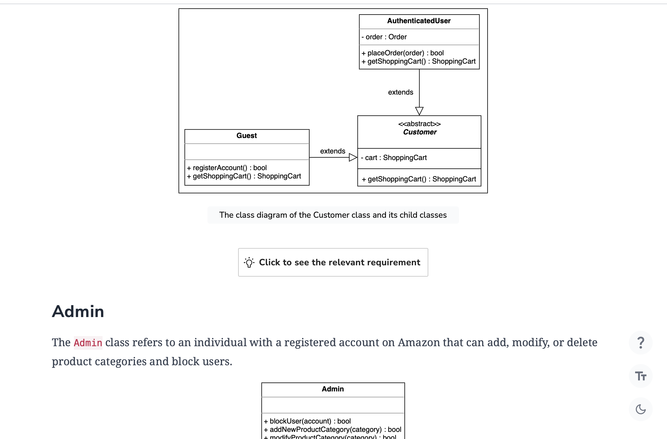

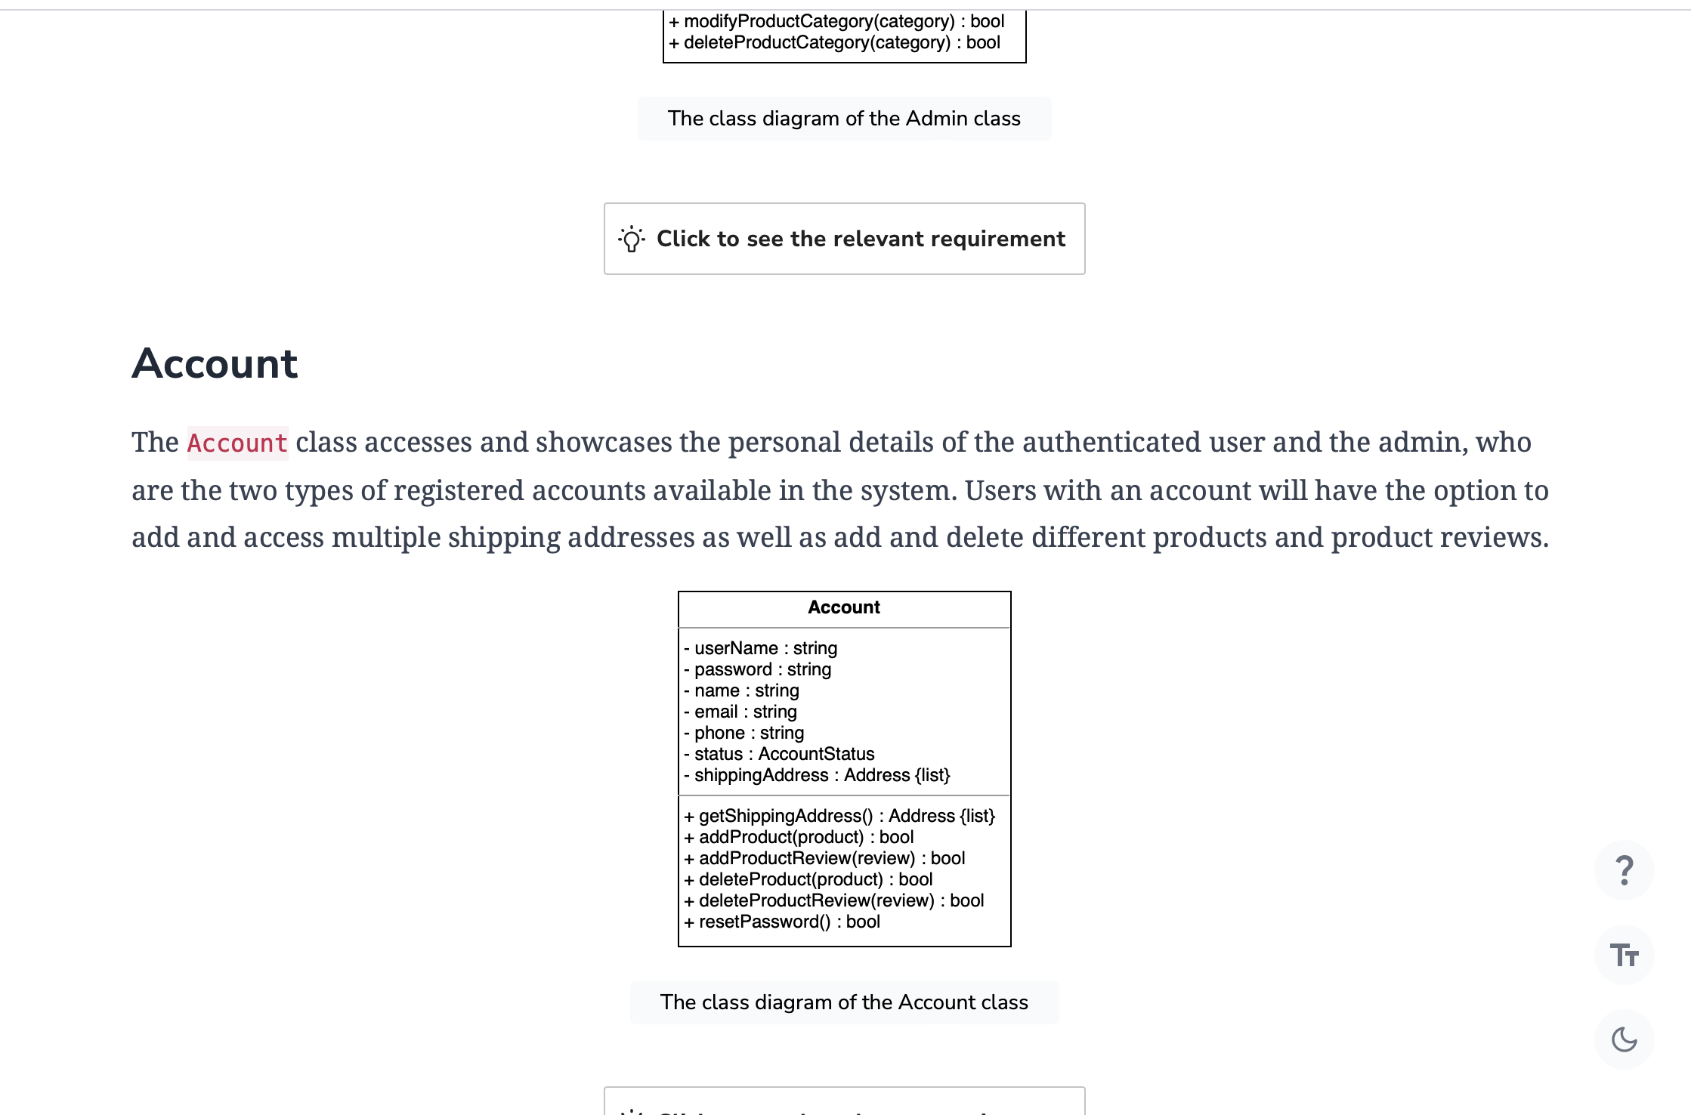

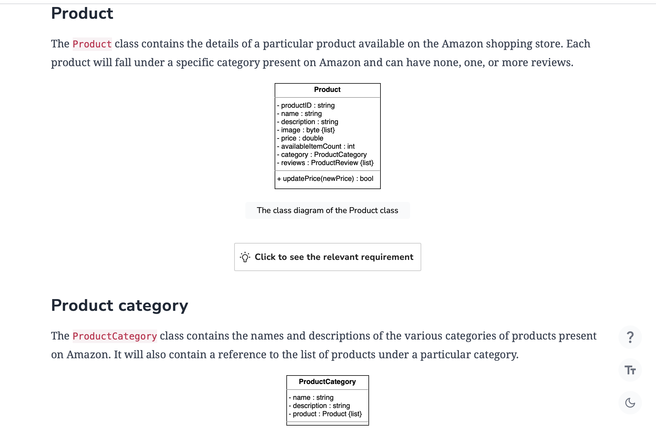

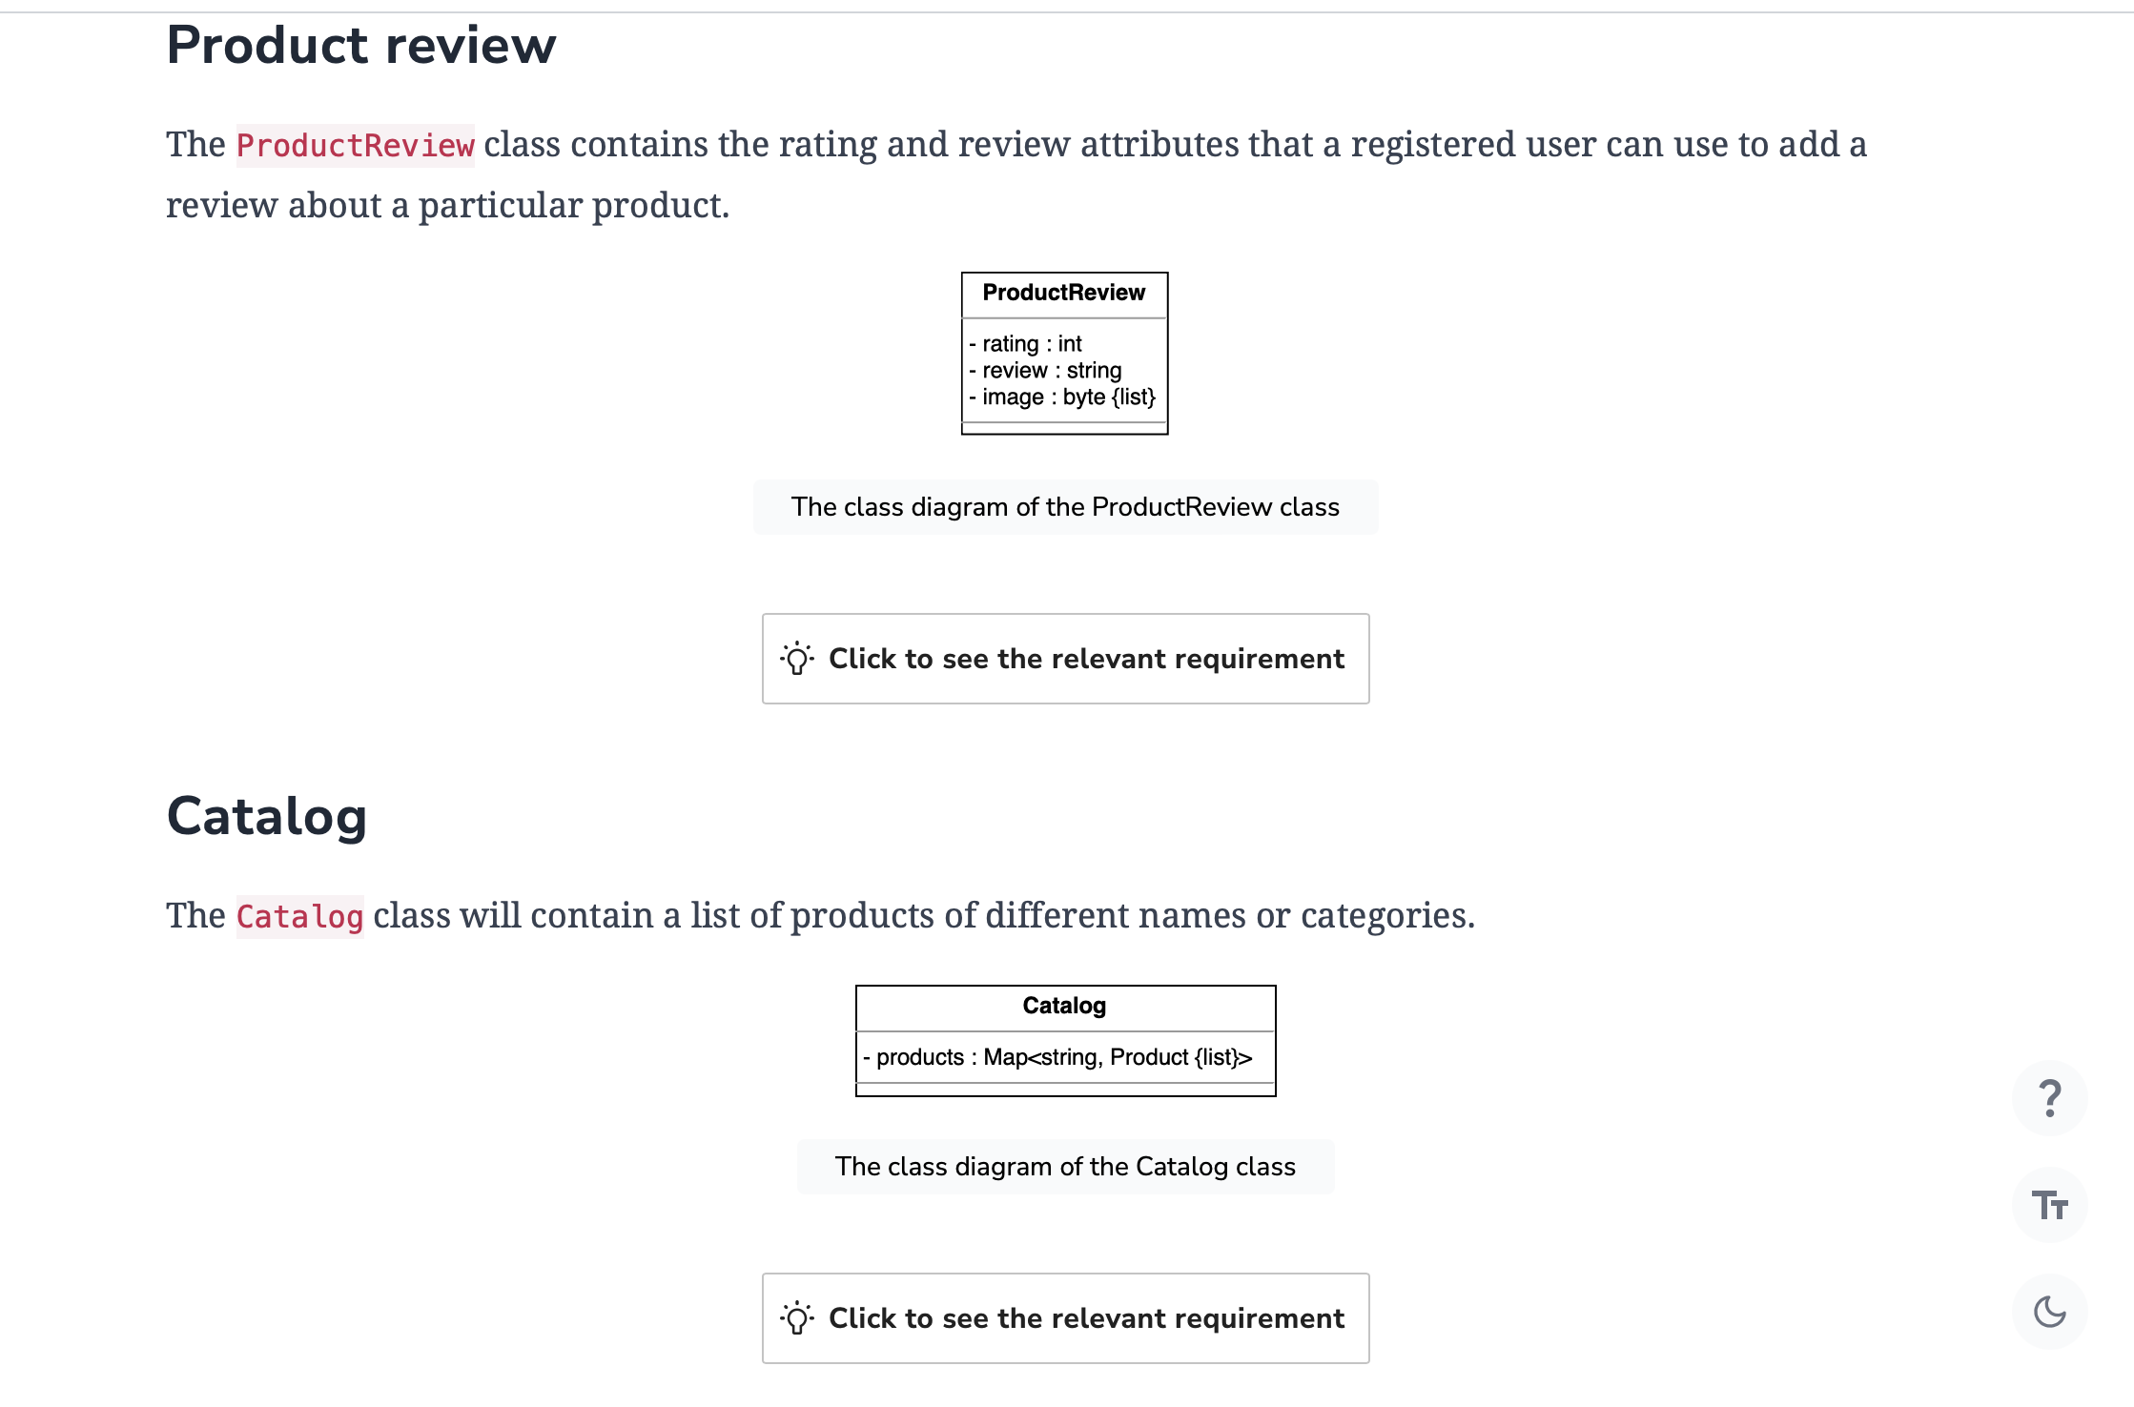

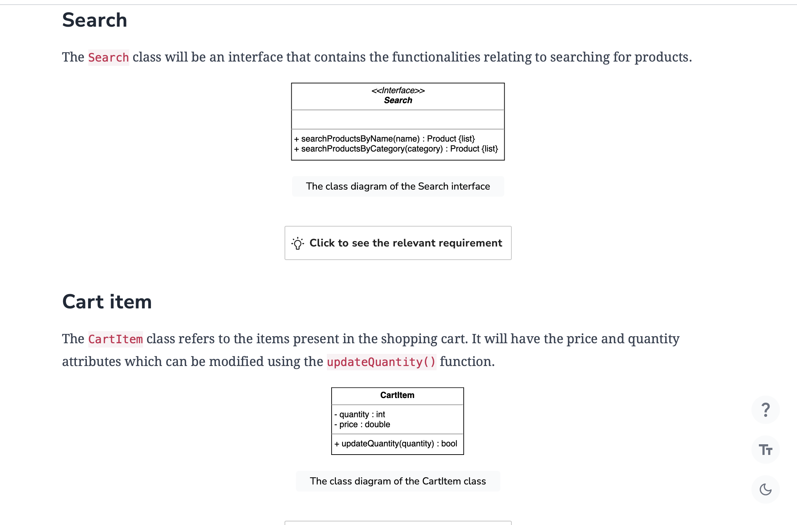

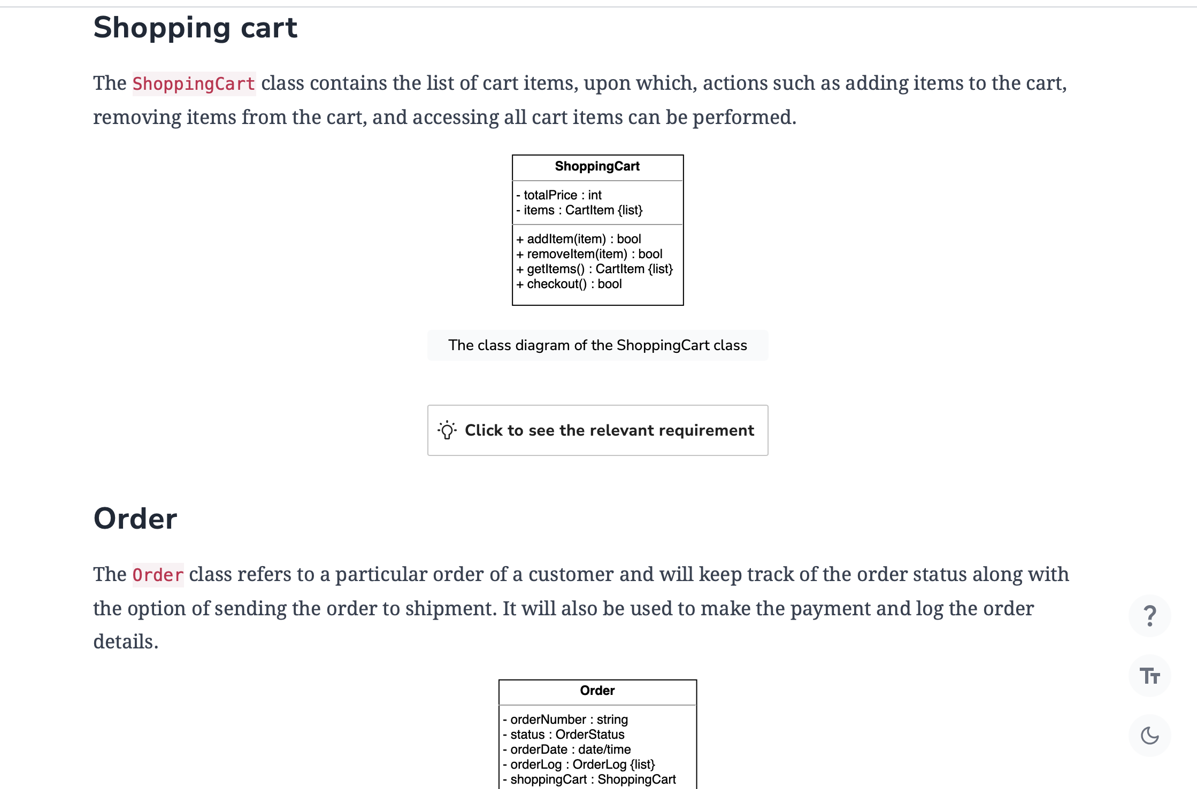

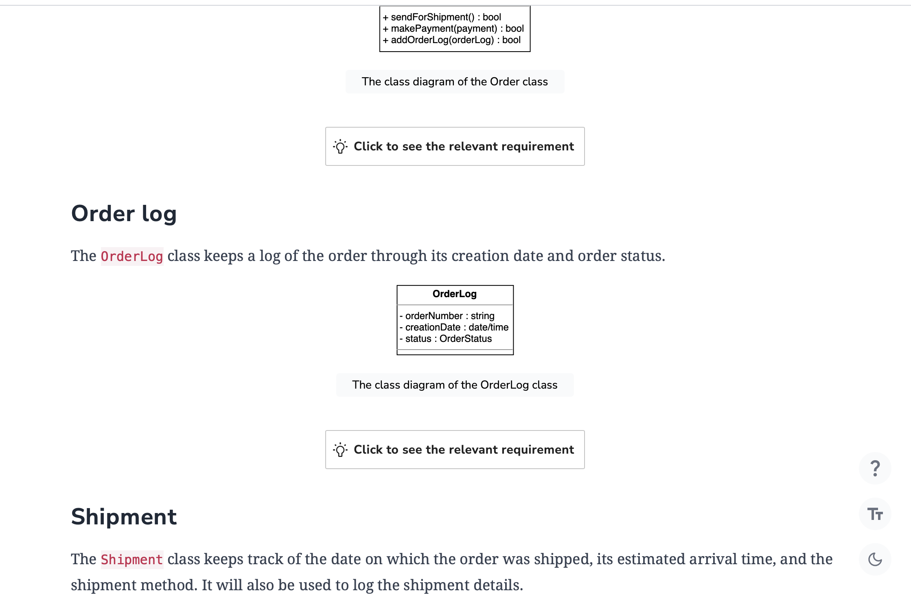

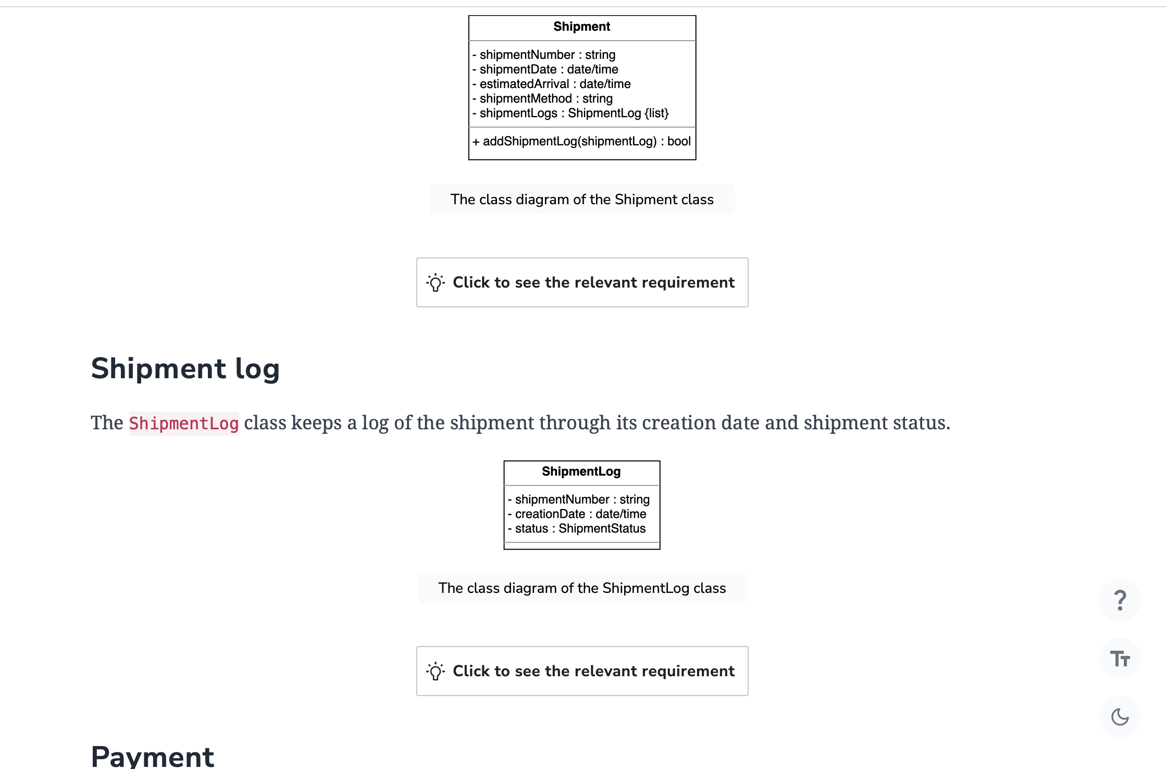

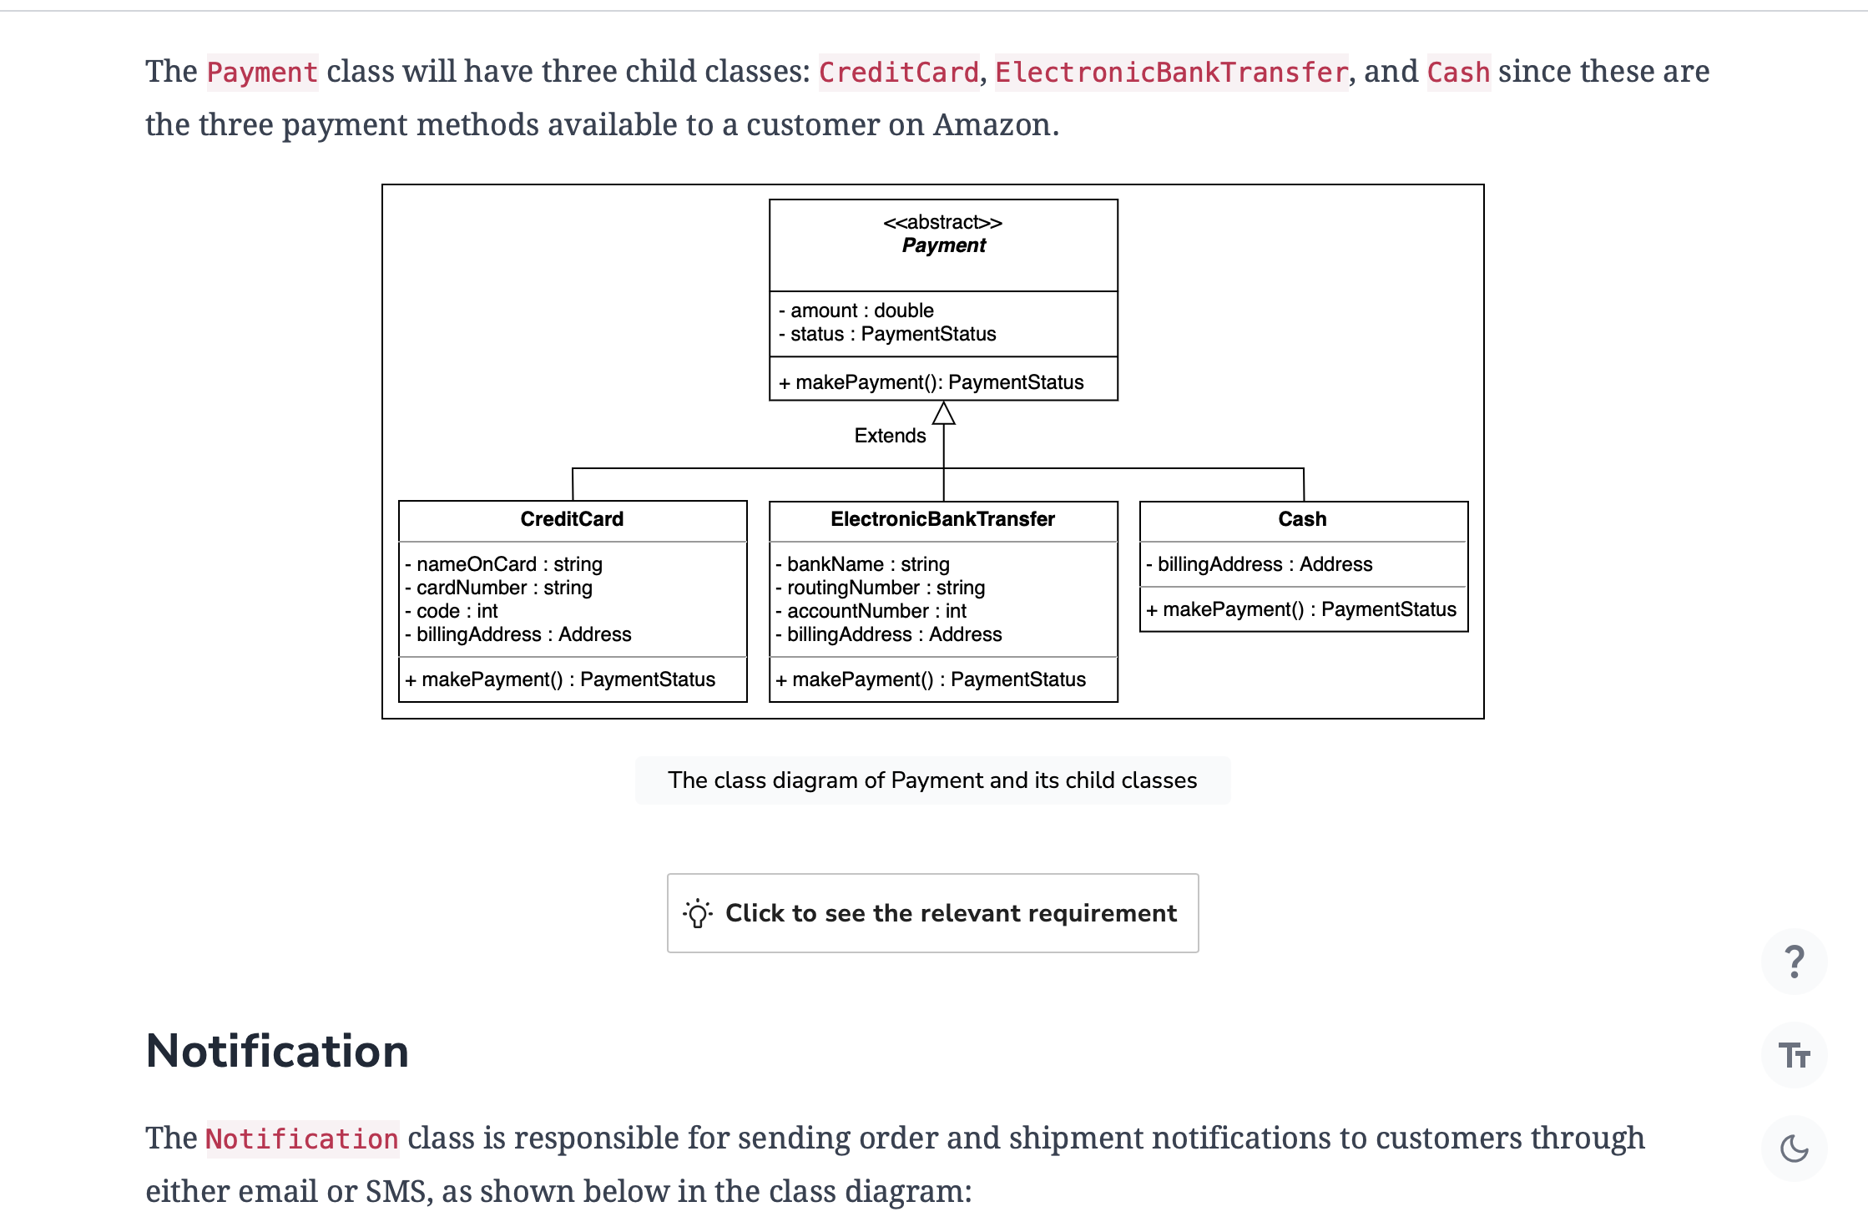

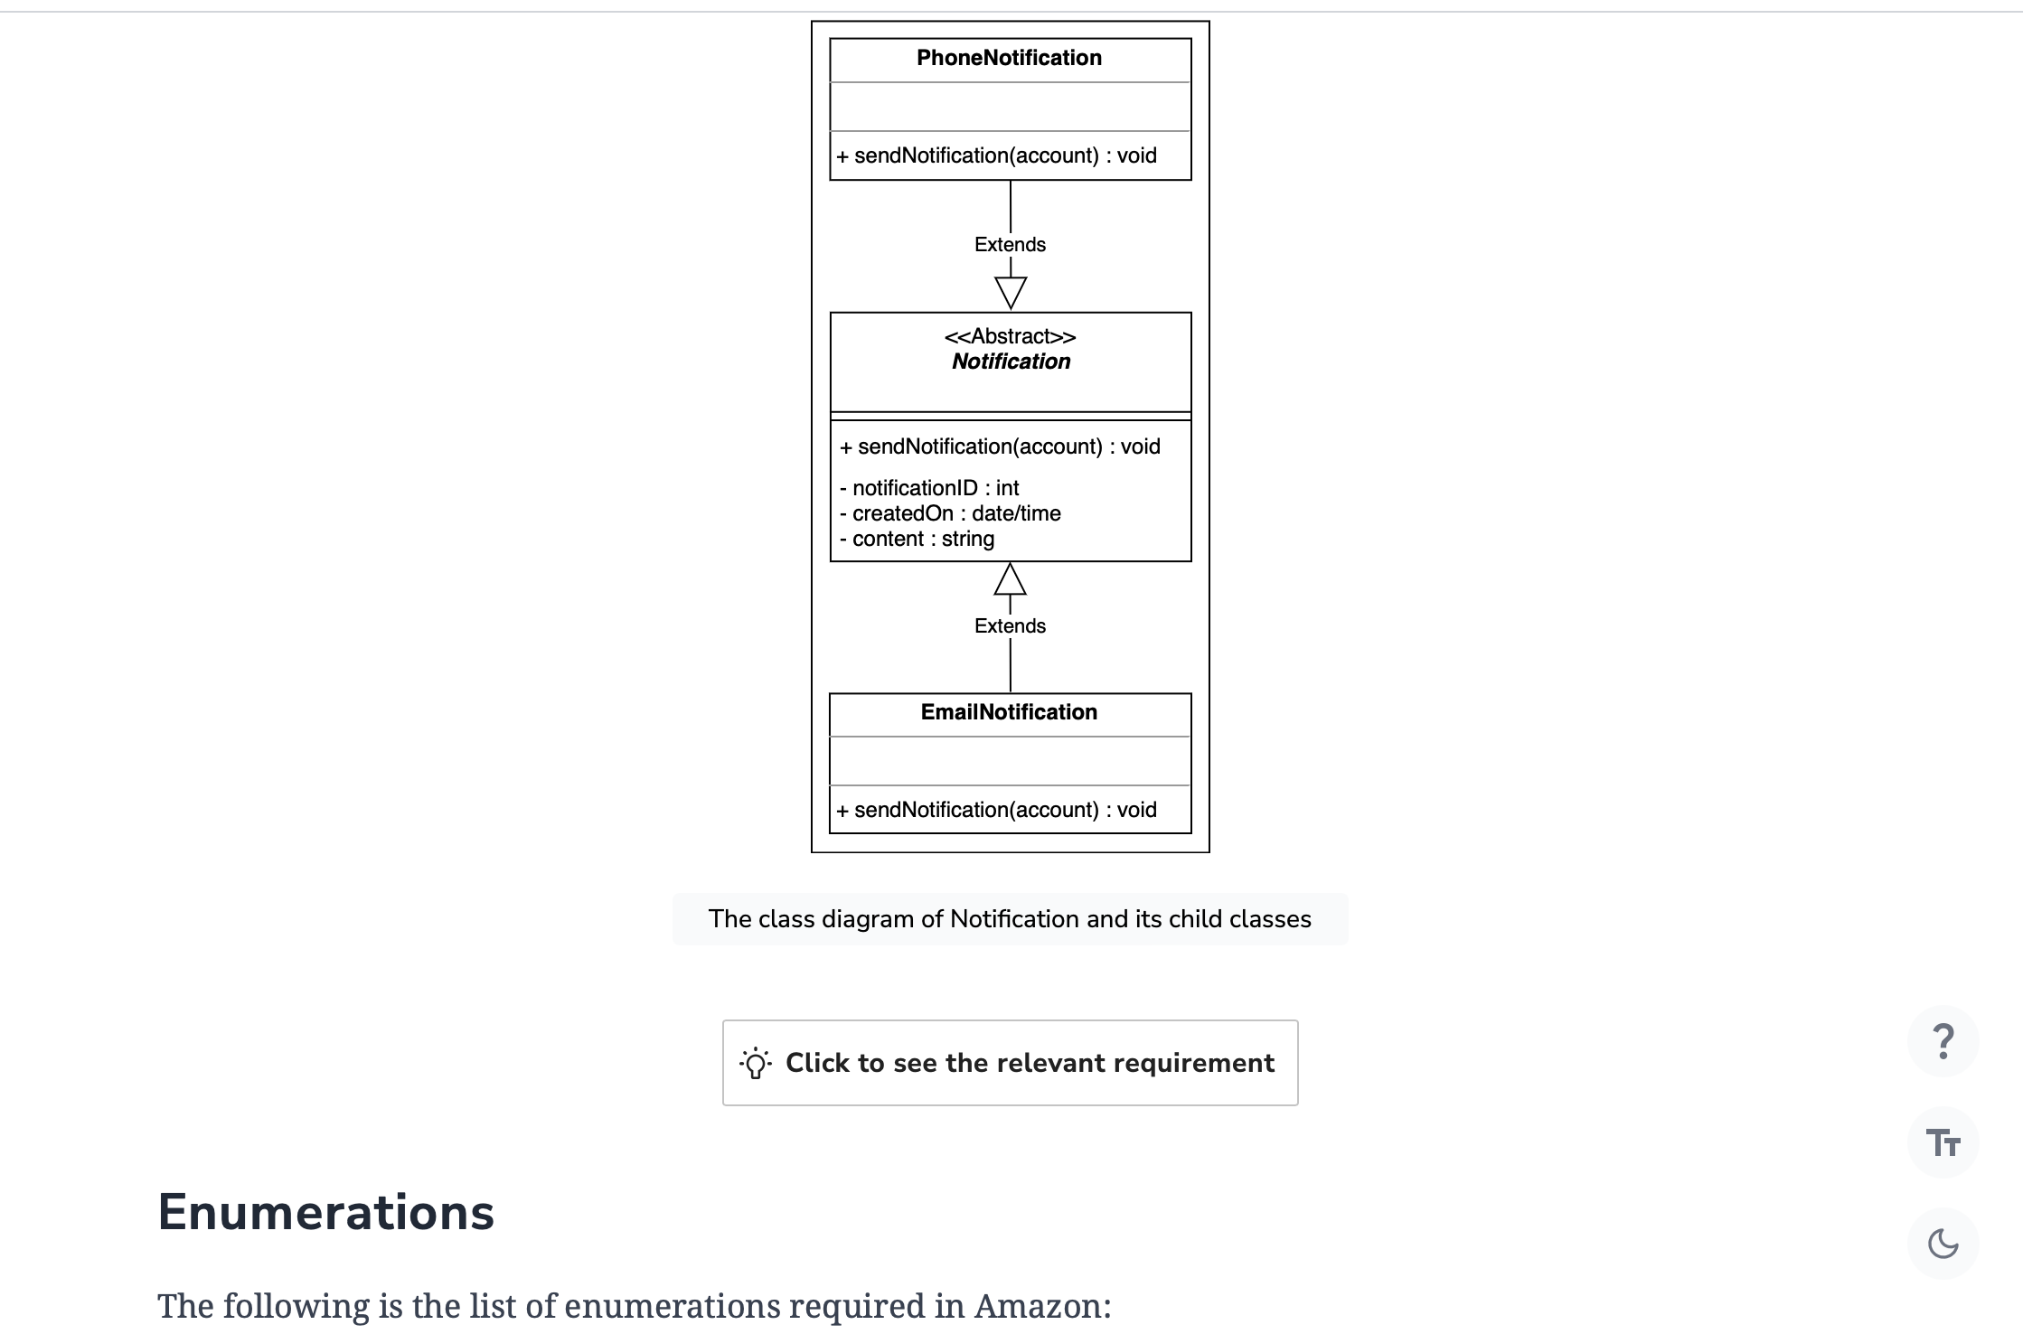

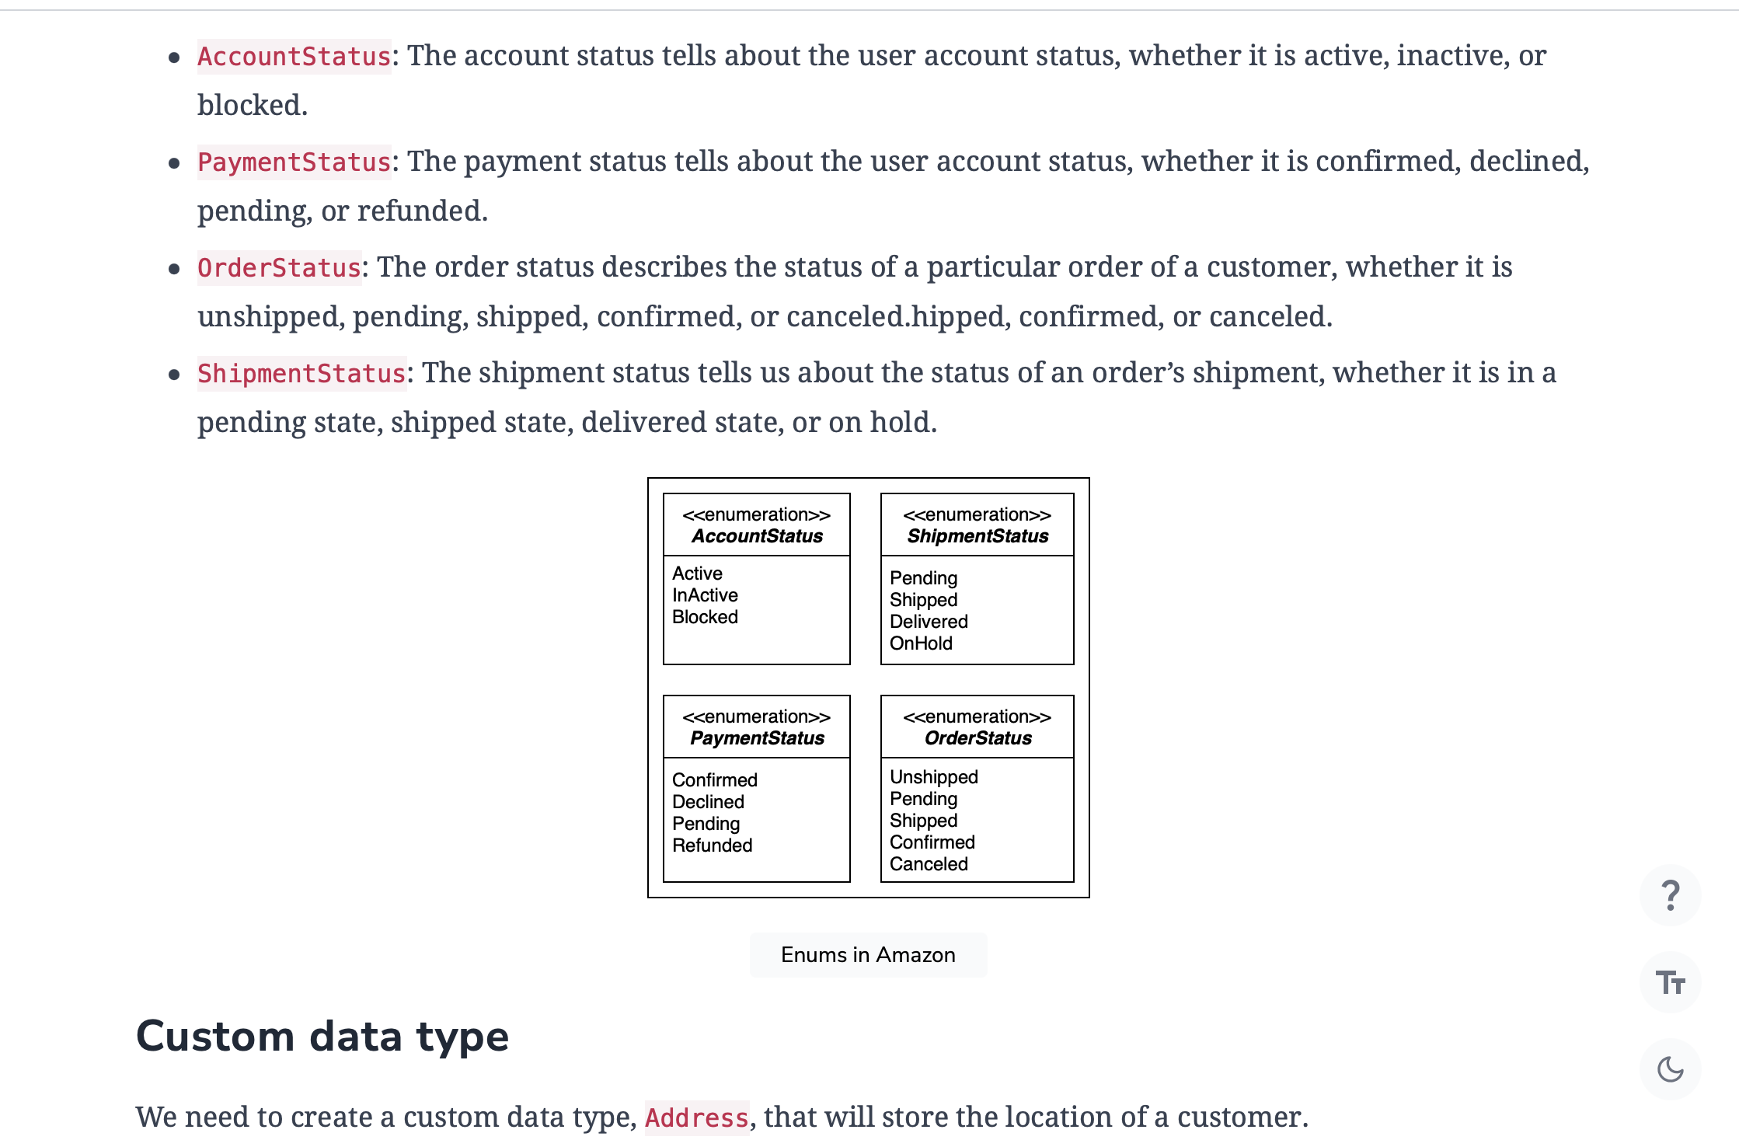

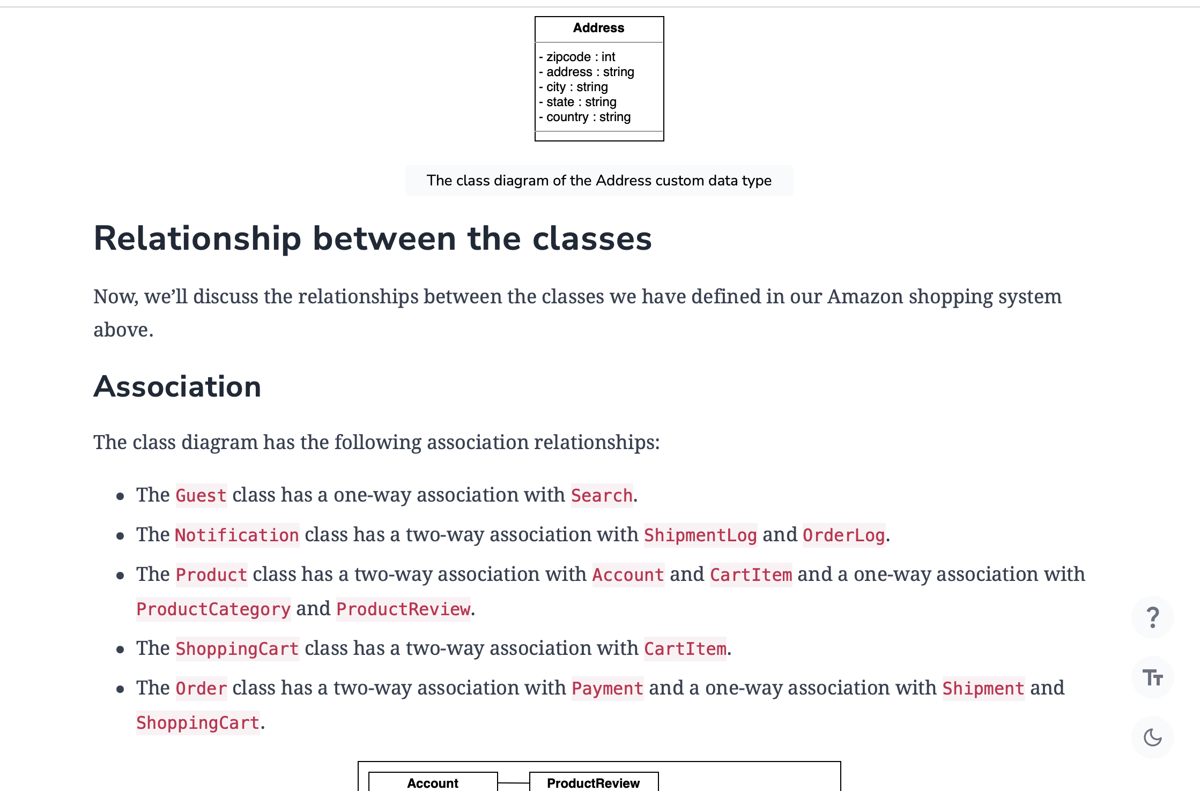

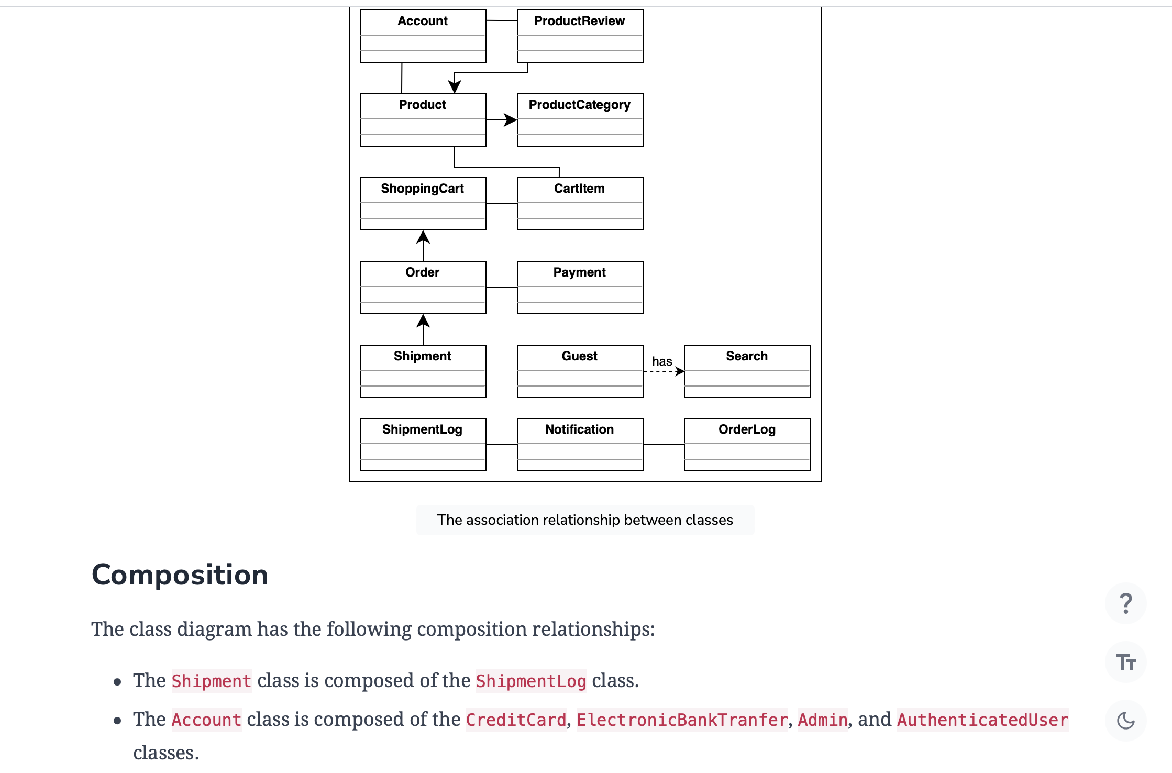

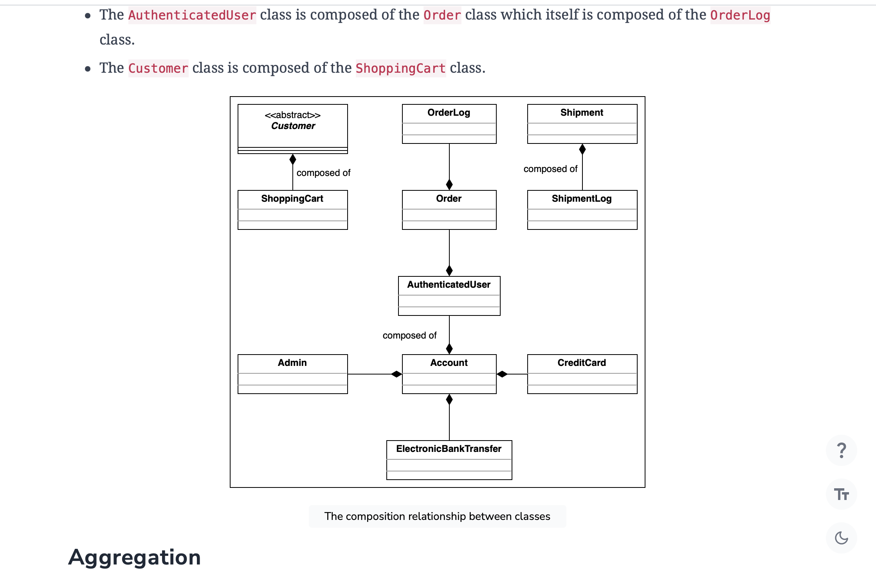

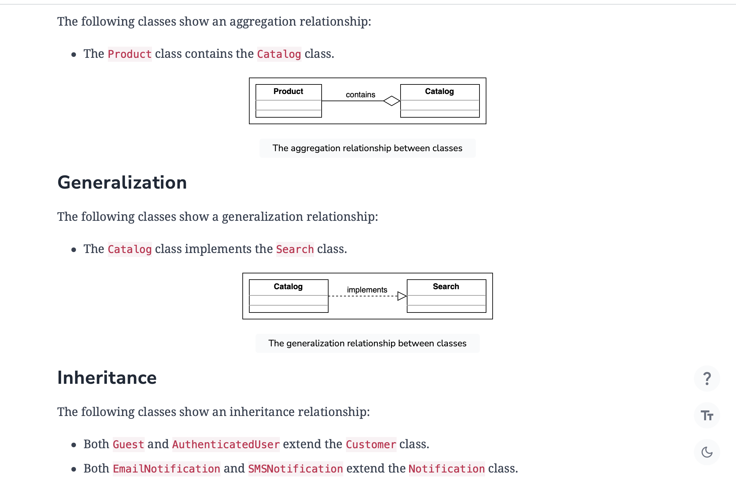

* Subclasses Cash, ElectronicBankTransfer, and CreditCard extend the Payment class.

**Note:** We have already discussed the inheritance relationship between classes in the component section above.

## Class diagram of Amazon

Here’s the complete class diagram for Amazon:

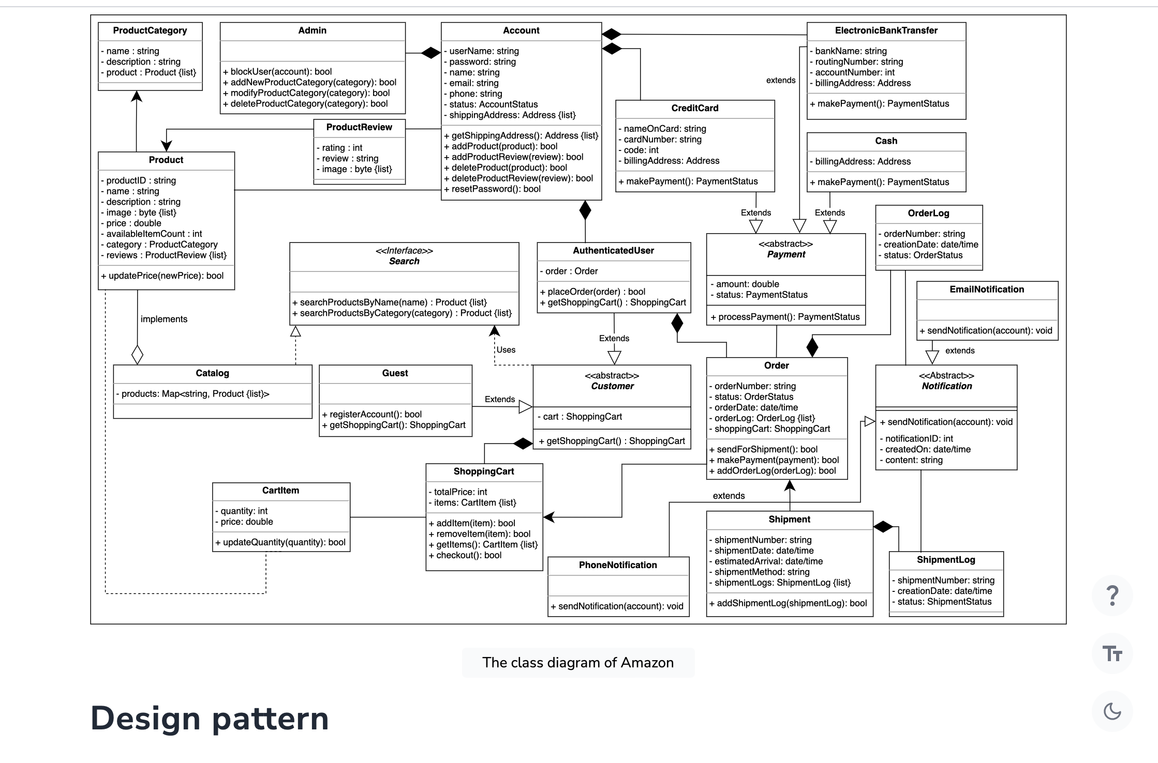

In the Amazon online shopping system, we can use the Factory design pattern to maintain different orders and the bill generation process based on the products selected by a customer.

We know that in the Amazon-online shopping system, various items are on sale, or items can be bought using special coupons that give different percentage discounts. To effectively calculate prices for different discount types, we can use the Strategy design pattern. This pattern allows us to design a separate strategy or algorithm to calculate the prices for each discount type.

## Additional requirements

The interviewer can introduce some additional requirements in the Amazon shopping system, or they can ask some follow-up questions. Let’s see some examples of additional requirements:

**Wish list**: Only users with an account (an authenticated user) can add a product to their wishlist. The WishList class can be used to move products to a cart and also check if it is currently available:

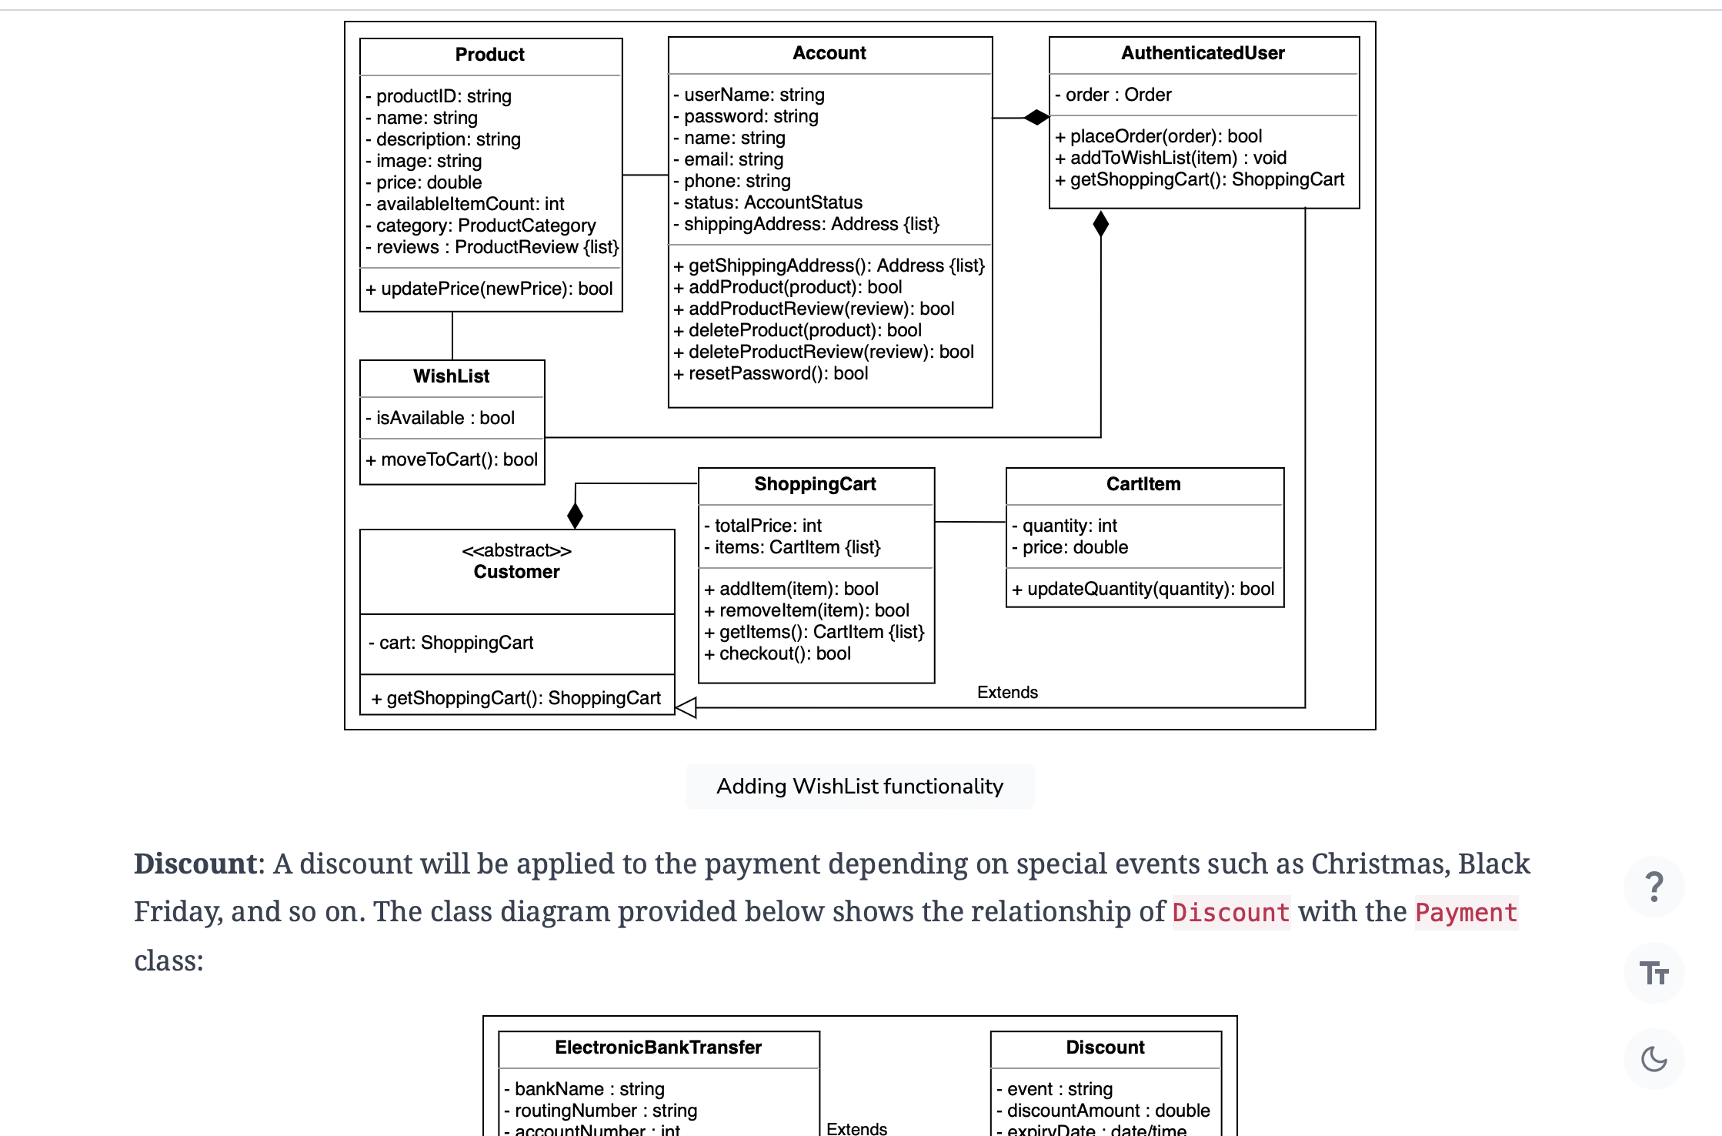

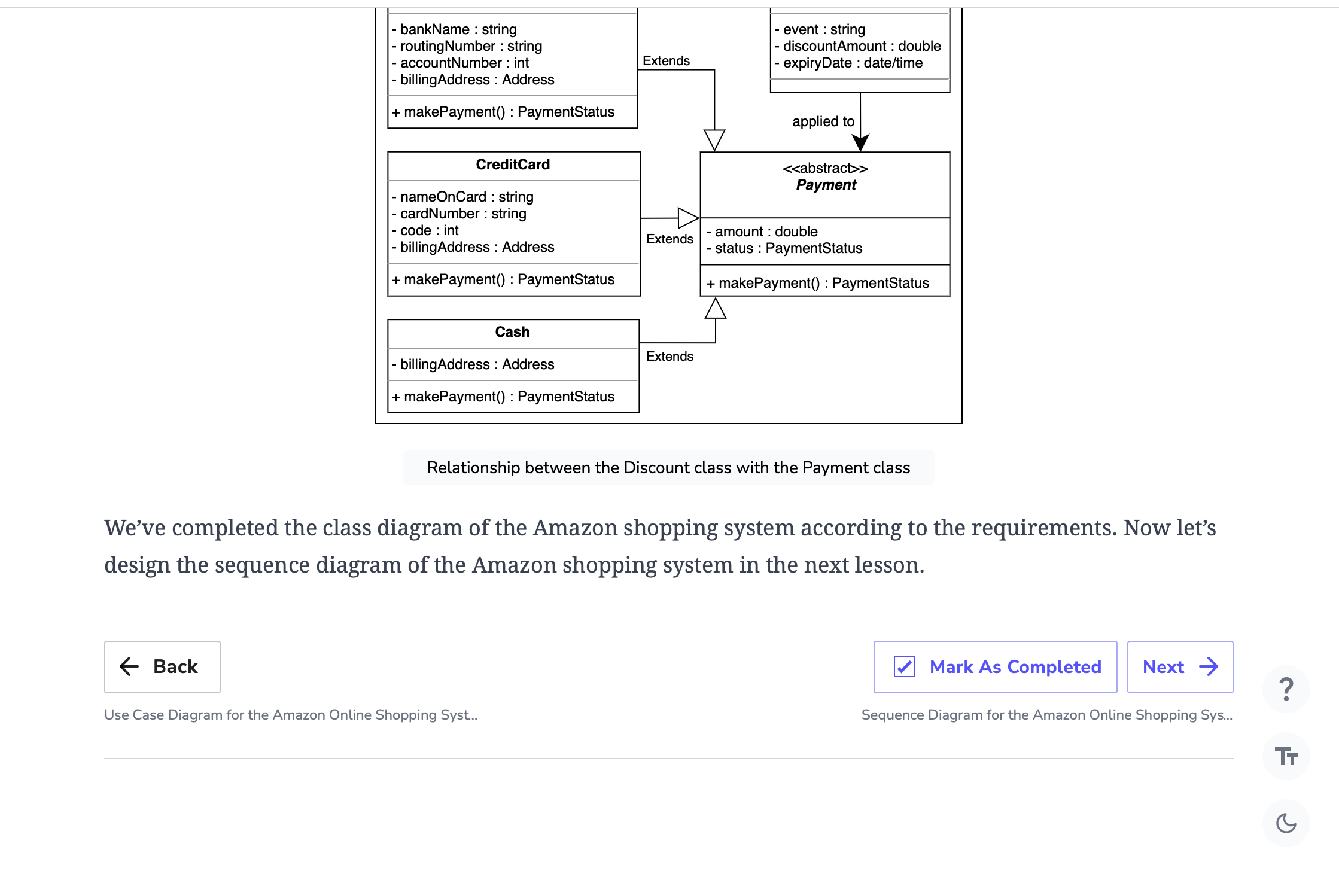

# Sequence Diagram for the Amazon Online Shopping System

Create a sequence diagram for checkout and payment of an order, and solve a challenge.

**We'll cover the following**

* [Checkout and payment](https://www.educative.io/courses/grokking-the-low-level-design-interview-using-ood-principles/getting-ready-the-amazon-online-shopping-system#Checkout-and-payment)
* [Sequence challenge: Search and add items to the cart](https://www.educative.io/courses/grokking-the-low-level-design-interview-using-ood-principles/getting-ready-the-amazon-online-shopping-system#Sequence-challenge:-Search-and-add-items-to-the-cart)

Sequence diagrams are a great way to understand the interactions between different entities and objects in the system. There can be different sequence diagrams that we can create for the Amazon online shopping system. For this lesson, we’ll create sequence diagrams for the following two interactions:

* **Checkout and payment:** The user checks out and pays for their order using a credit card.
* **Sequence challenge:** The user searches and adds an item to the shopping cart.

## Checkout and payment

The sequence diagram for order checkout and payment should have the following actors and objects that will interact with each other:

* **Actor:** Customer
* **Objects:**ShoppingCart, Order, Item, and Payment

Here’re the steps in the order checkout and payment interaction:

1. The customer requests the shopping cart items and amount.
2. The customer then places the order for the requested items.
3. The items are verified for availability.
4. If the item quantity is less than the available count:
   1. The order status is updated.
   2. The customer is informed that the order is ready for payment.
   3. The customer initiates a payment against the order amount using their card.
   4. The payment is processed.
   5. The customer is informed of the updated payment status.
5. Else if the item quantity is greater than the available count:
   1. The item in the order is unavailable.
   2. The customer receives an error for the unavailable item.

Based on the order above, the sequence diagram below represents the order checkout and payment process in an online shopping system.

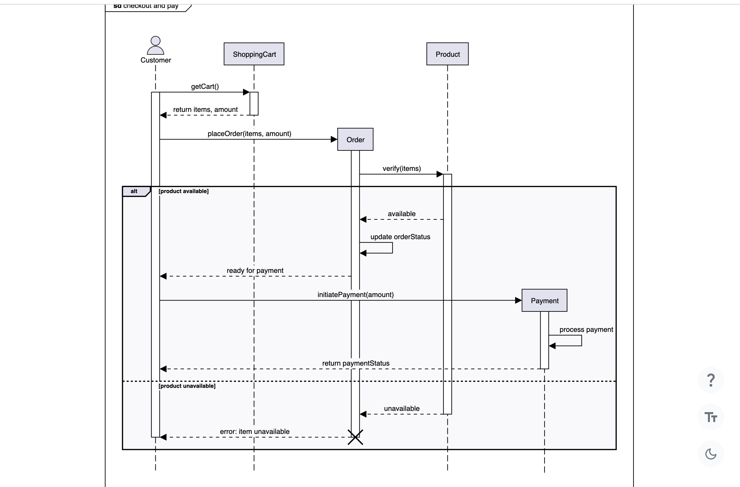

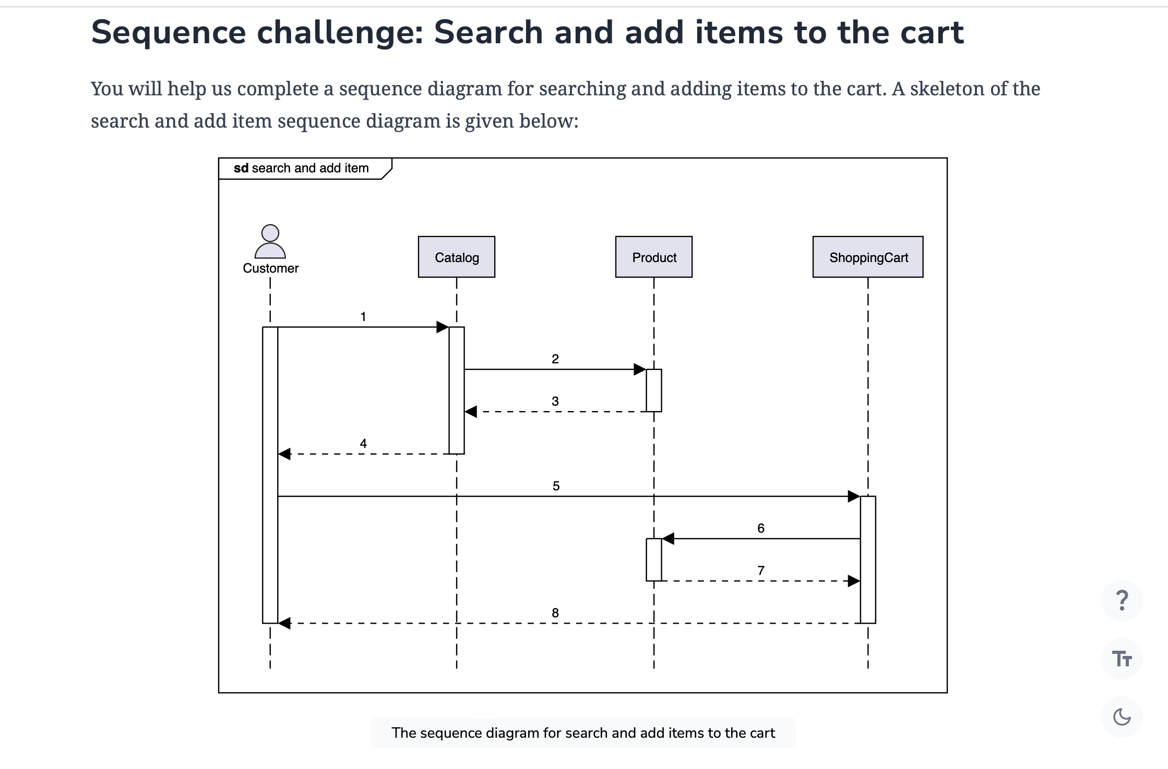

Notice that the arrows in the diagram above are numbered from 1 to 8. The message boxes shown below are the messages to be exchanged between the actor(s) and object(s). Can you rearrange the messages below in the correct sequence of order they should appear in the skeleton of the sequence diagram provided above?

**Note:** If you get stuck, just click the “Show Solution” button to check the correct answer.

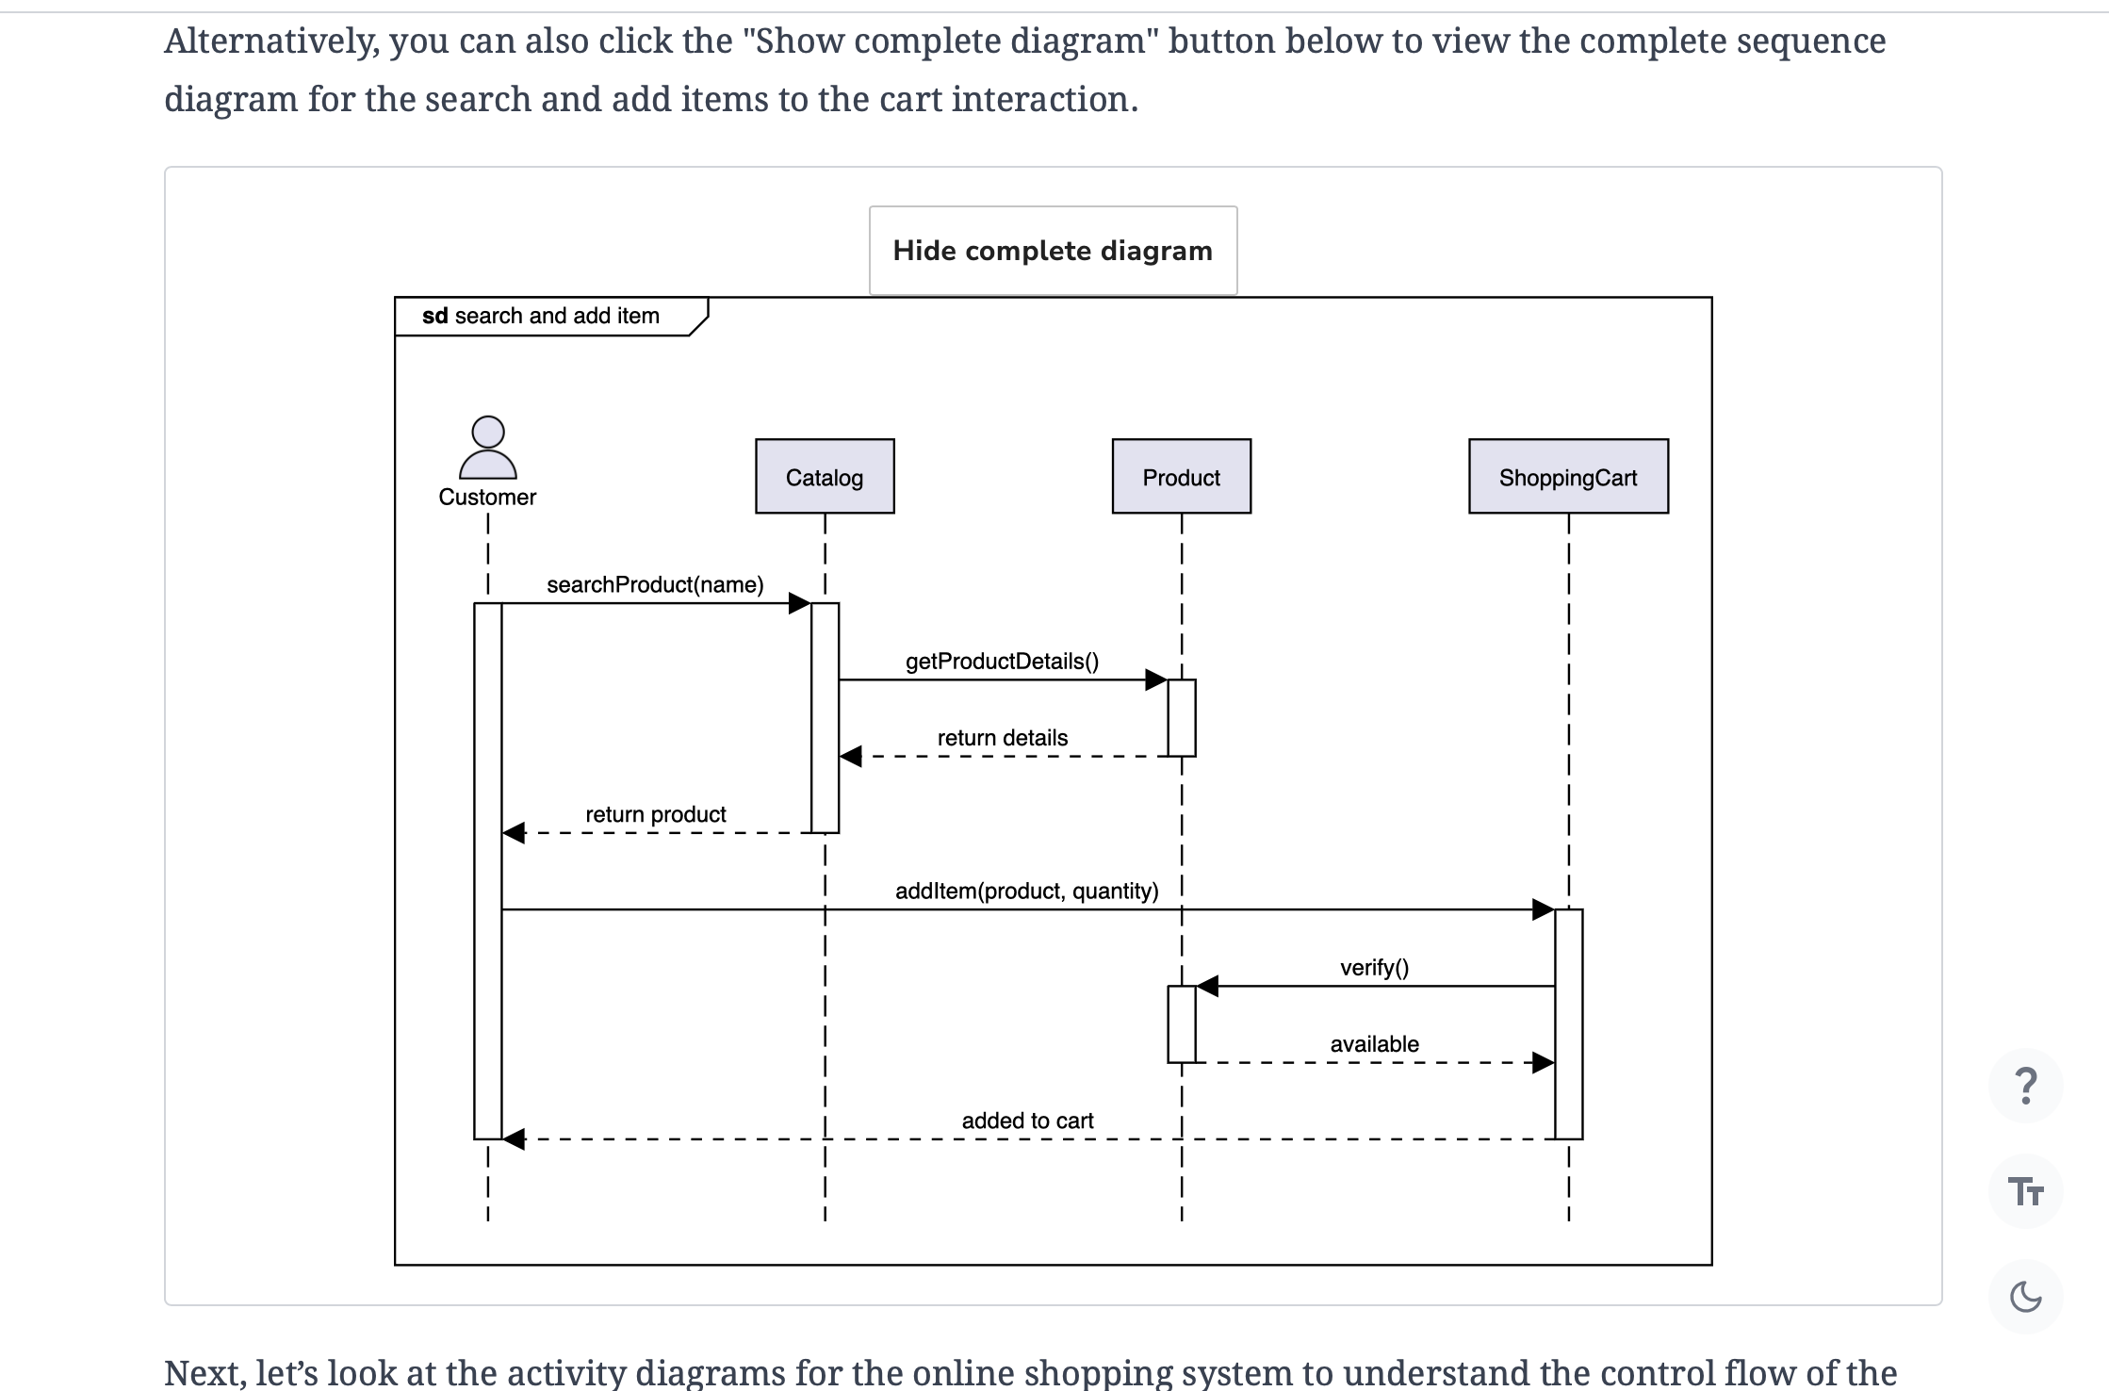

# Activity Diagram for the Amazon Online Shopping System

Create some activity diagrams for the Amazon online shopping system.

**We'll cover the following**

* [A customer buying a product](https://www.educative.io/courses/grokking-the-low-level-design-interview-using-ood-principles/getting-ready-the-amazon-online-shopping-system#A-customer-buying-a-product)
  + [States](https://www.educative.io/courses/grokking-the-low-level-design-interview-using-ood-principles/getting-ready-the-amazon-online-shopping-system#States)
  + [Actions](https://www.educative.io/courses/grokking-the-low-level-design-interview-using-ood-principles/getting-ready-the-amazon-online-shopping-system#Actions)
* [Activity challenge: The customer receives their order](https://www.educative.io/courses/grokking-the-low-level-design-interview-using-ood-principles/getting-ready-the-amazon-online-shopping-system#Activity-challenge:-The-customer-receives-their-order)

Activities diagrams are a great way to visualize the flow of messages from one activity to the other in the system. There can be different activity diagrams that we can create for our Amazon online shopping system. In this lesson, we will create activity diagrams for the following two activities:

* A customer buying a product
* **Activity challenge:**The customer receives their order.

## A customer buying a product

The following are the states and actions that will be involved in this activity diagram.

### States

**Initial state:**The customer opens Amazon.

**Final state:** The customer proceeds with checkout.

### Actions

The customer opens the website. They either search or browse the website, select a product, and proceed to buy it.

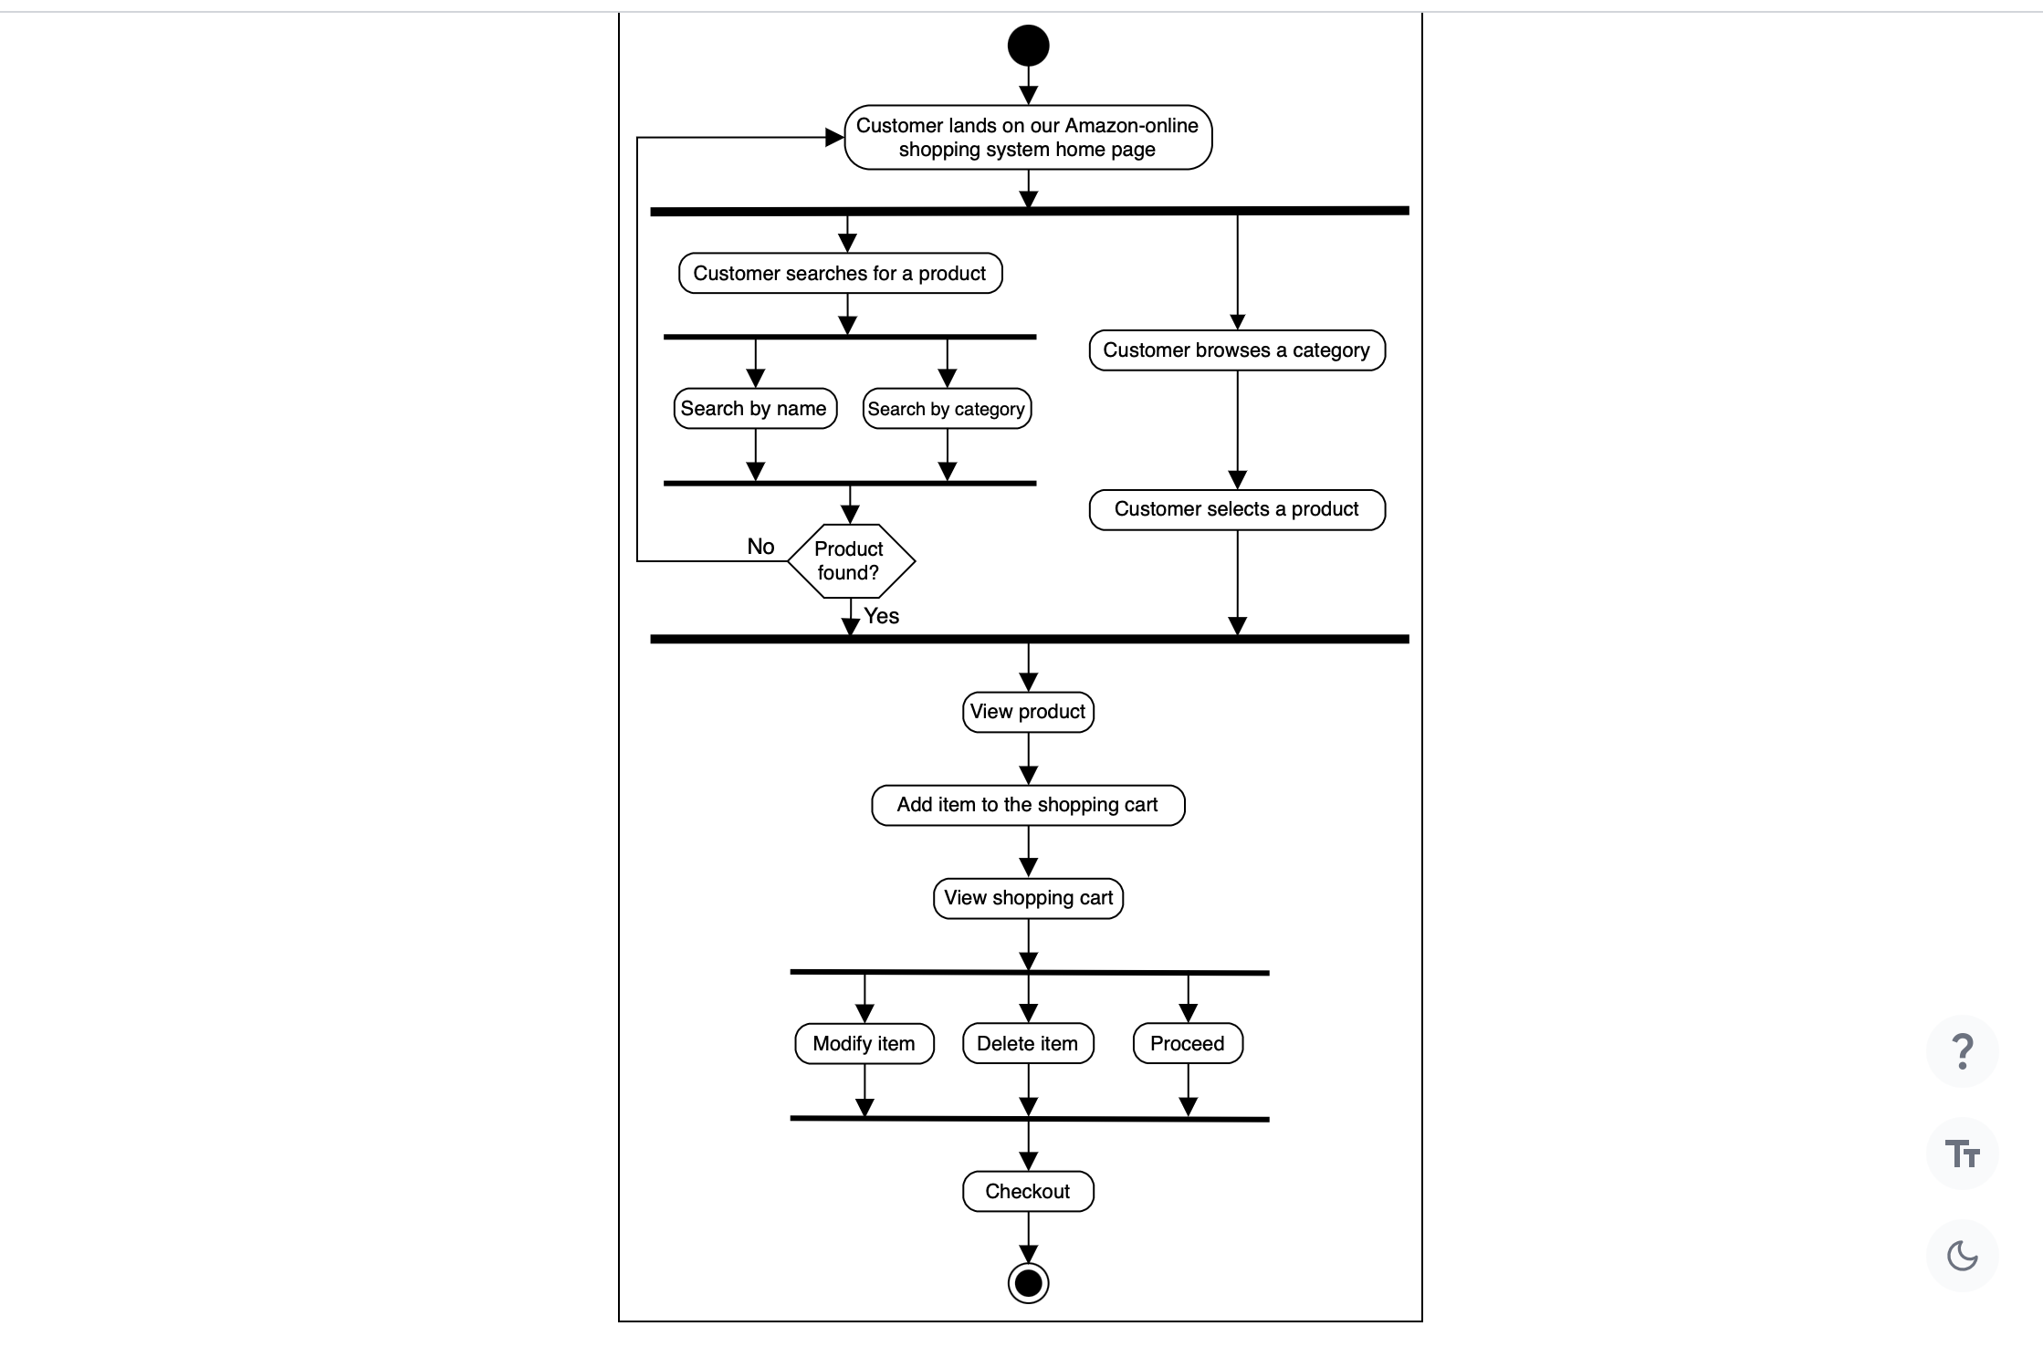

## Activity challenge: The customer receives their order

You’ll help us in creating an activity diagram of a customer receiving their order.

A skeleton of the activity diagram is provided below.

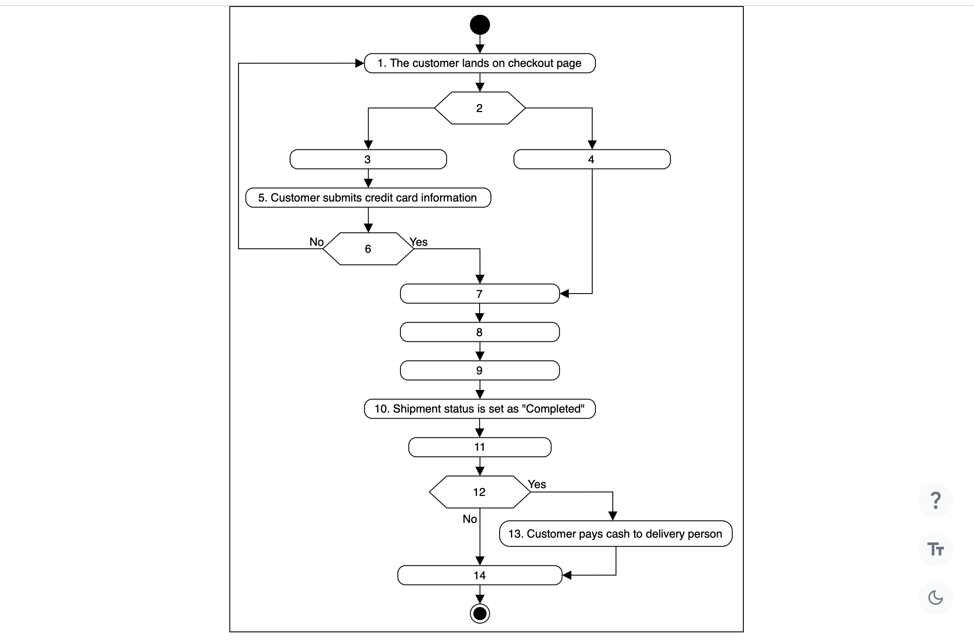

Notice that the actions in the diagram above are numbered from 1 to 14. The slots below represent the activities, and the arrows represent the flow from one activity to the other.

Can you rearrange the slots below in the correct order they should appear in the activity diagram above?

**Note:** If you get stuck, just click the “Show Solution” button to check the correct answer.

Alternatively, you can click the "Show complete diagram" button below to see the complete activity diagram.

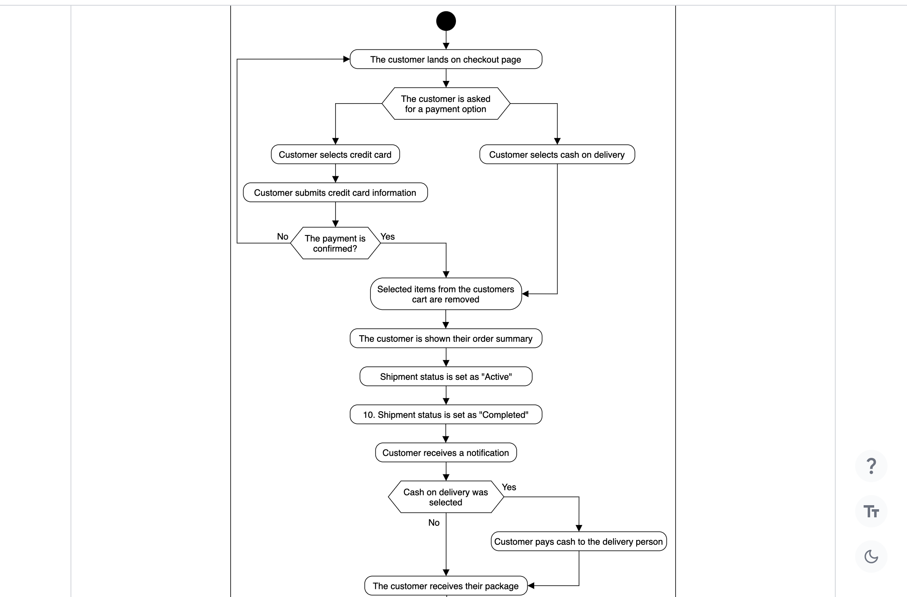

We’ve looked at some of the activity diagrams of our Amazon online shopping system. In the next lesson, we’ll present the code for our designed classes in some of the most popular languages.

# Code for the Amazon Online Shopping System

Write the object-oriented code to implement the design of the Amazon problem.

**We'll cover the following**

* [Amazon classes](https://www.educative.io/courses/grokking-the-low-level-design-interview-using-ood-principles/getting-ready-the-amazon-online-shopping-system#Amazon-classes)
  + [Constants](https://www.educative.io/courses/grokking-the-low-level-design-interview-using-ood-principles/getting-ready-the-amazon-online-shopping-system#Constants)
  + [Account](https://www.educative.io/courses/grokking-the-low-level-design-interview-using-ood-principles/getting-ready-the-amazon-online-shopping-system#Account)
  + [Admin](https://www.educative.io/courses/grokking-the-low-level-design-interview-using-ood-principles/getting-ready-the-amazon-online-shopping-system#Admin)
  + [Customer](https://www.educative.io/courses/grokking-the-low-level-design-interview-using-ood-principles/getting-ready-the-amazon-online-shopping-system#Customer)
  + [Product, product category, and product review](https://www.educative.io/courses/grokking-the-low-level-design-interview-using-ood-principles/getting-ready-the-amazon-online-shopping-system#Product,-product-category,-and-product-review)
  + [Shopping cart and cart items](https://www.educative.io/courses/grokking-the-low-level-design-interview-using-ood-principles/getting-ready-the-amazon-online-shopping-system#Shopping-cart-and-cart-items)
  + [Order and order log](https://www.educative.io/courses/grokking-the-low-level-design-interview-using-ood-principles/getting-ready-the-amazon-online-shopping-system#Order-and-order-log)
  + [Shipment and shipment log](https://www.educative.io/courses/grokking-the-low-level-design-interview-using-ood-principles/getting-ready-the-amazon-online-shopping-system#Shipment-and-shipment-log)
  + [Payment](https://www.educative.io/courses/grokking-the-low-level-design-interview-using-ood-principles/getting-ready-the-amazon-online-shopping-system#Payment)
  + [Notification](https://www.educative.io/courses/grokking-the-low-level-design-interview-using-ood-principles/getting-ready-the-amazon-online-shopping-system#Notification)
  + [Search and catalog](https://www.educative.io/courses/grokking-the-low-level-design-interview-using-ood-principles/getting-ready-the-amazon-online-shopping-system#Search-and-catalog)
* [Wrapping up](https://www.educative.io/courses/grokking-the-low-level-design-interview-using-ood-principles/getting-ready-the-amazon-online-shopping-system#Wrapping-up)

We’ve gone over the different aspects of Amazon and observed the attributes attached to the problem using various UML diagrams. Let’s explore the more practical side of things, where we’ll implement Amazon using multiple languages. This is usually the last step in an object-oriented design interview process.

We have chosen the following languages to write the skeleton code of the different classes present in Amazon:

* Java
* C#
* Python
* C++
* JavaScript

## Amazon classes

In this section, we’ll provide the skeleton code of the classes designed in the class diagram lesson.

**Note:** For simplicity, we are not defining getter and setter functions. The reader can assume that all class attributes are private and accessed through their respective public getter methods and modified only through their public method functions.

### Constants

The following code provides the definition of the various enums and custom data types being used in the Amazon design:

**Note:** JavaScript does not support enumerations so we will be using the Object.freeze() method as an alternative that freezes an object and prevents further modifications.

Java

public class Address {

private int zipCode;

private String address;

private String city;

private String state;

private String country;

}

enum OrderStatus {

UNSHIPPED,

PENDING,

SHIPPED,

CONFIRMED,

CANCELED,

REFUNDED

}

enum AccountStatus {

ACTIVE,

INACTIVE,

BLOCKED

}

enum ShipmentStatus {

PENDING,

SHIPPED,

DELIVERED,

ON_HOLD

}

enum PaymentStatus {

CONFIRMED,

DECLINED,

PENDING,

REFUNDED

}

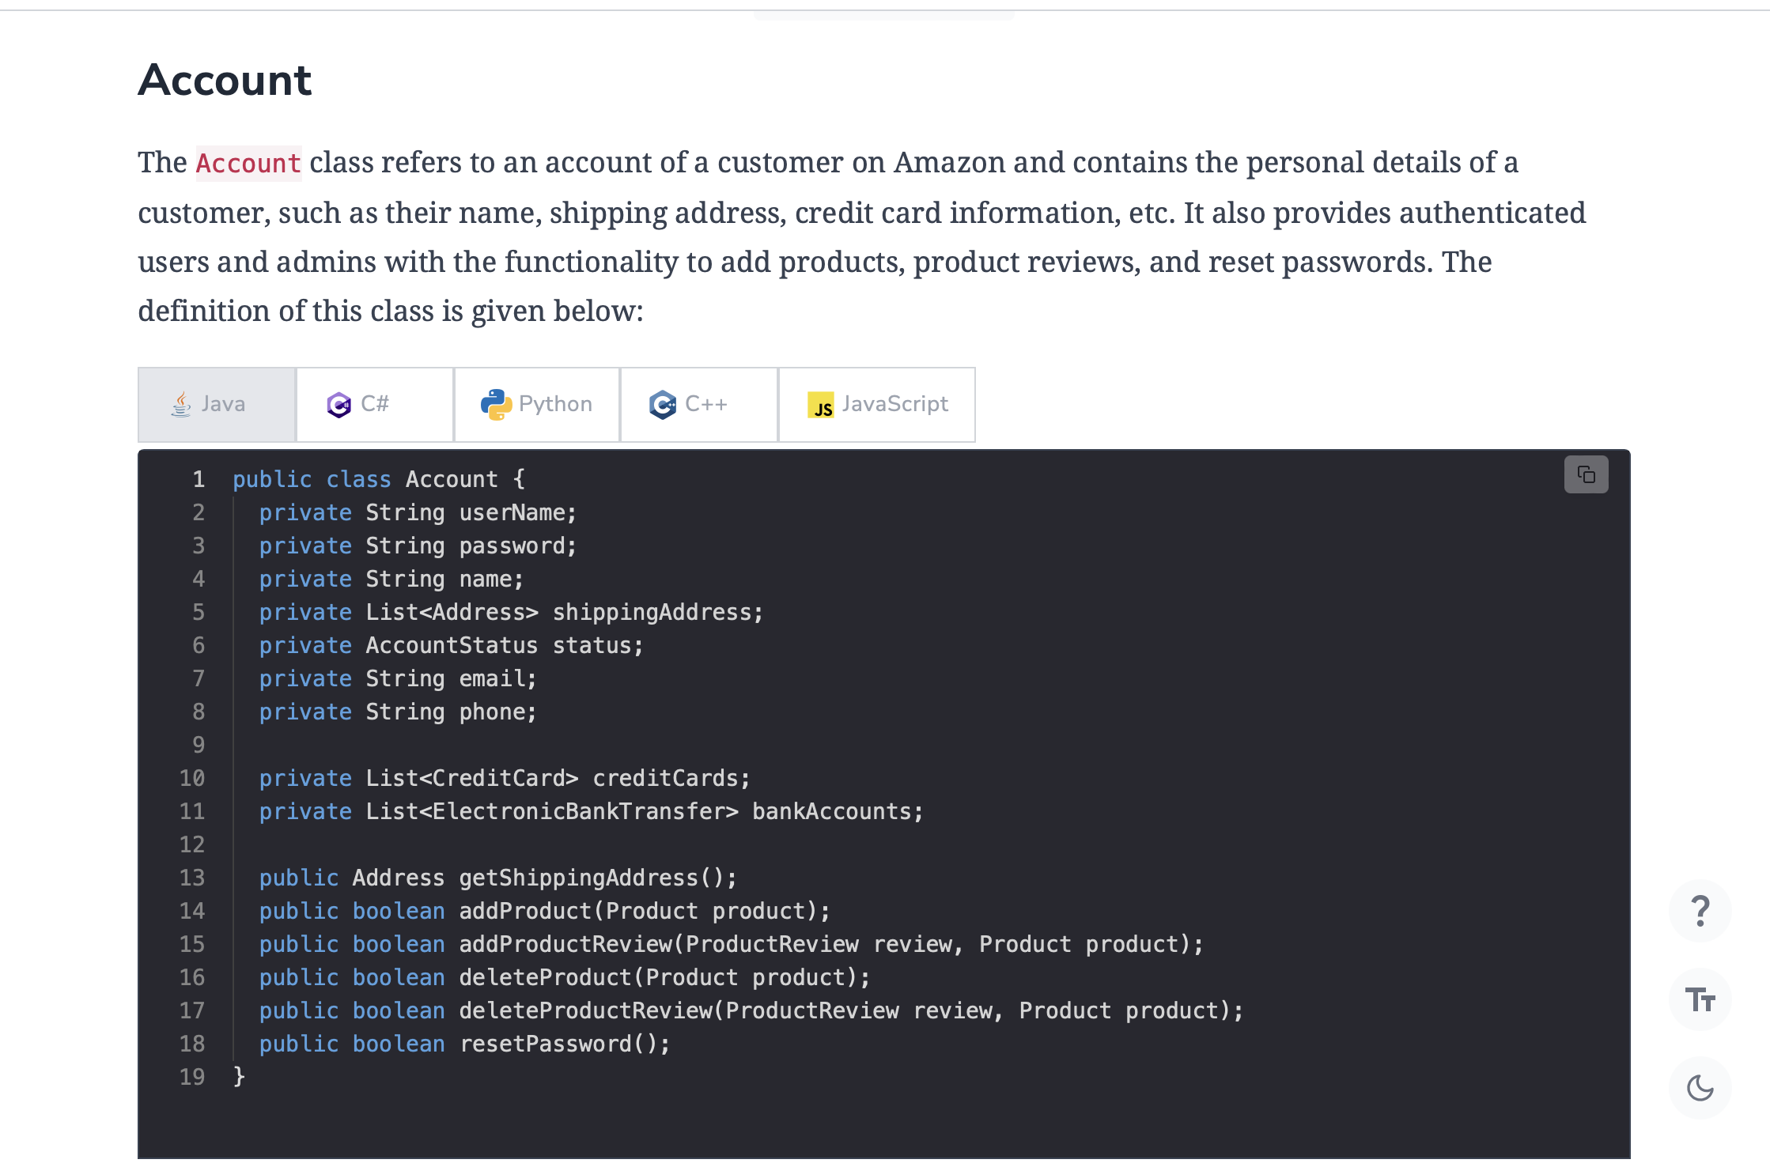

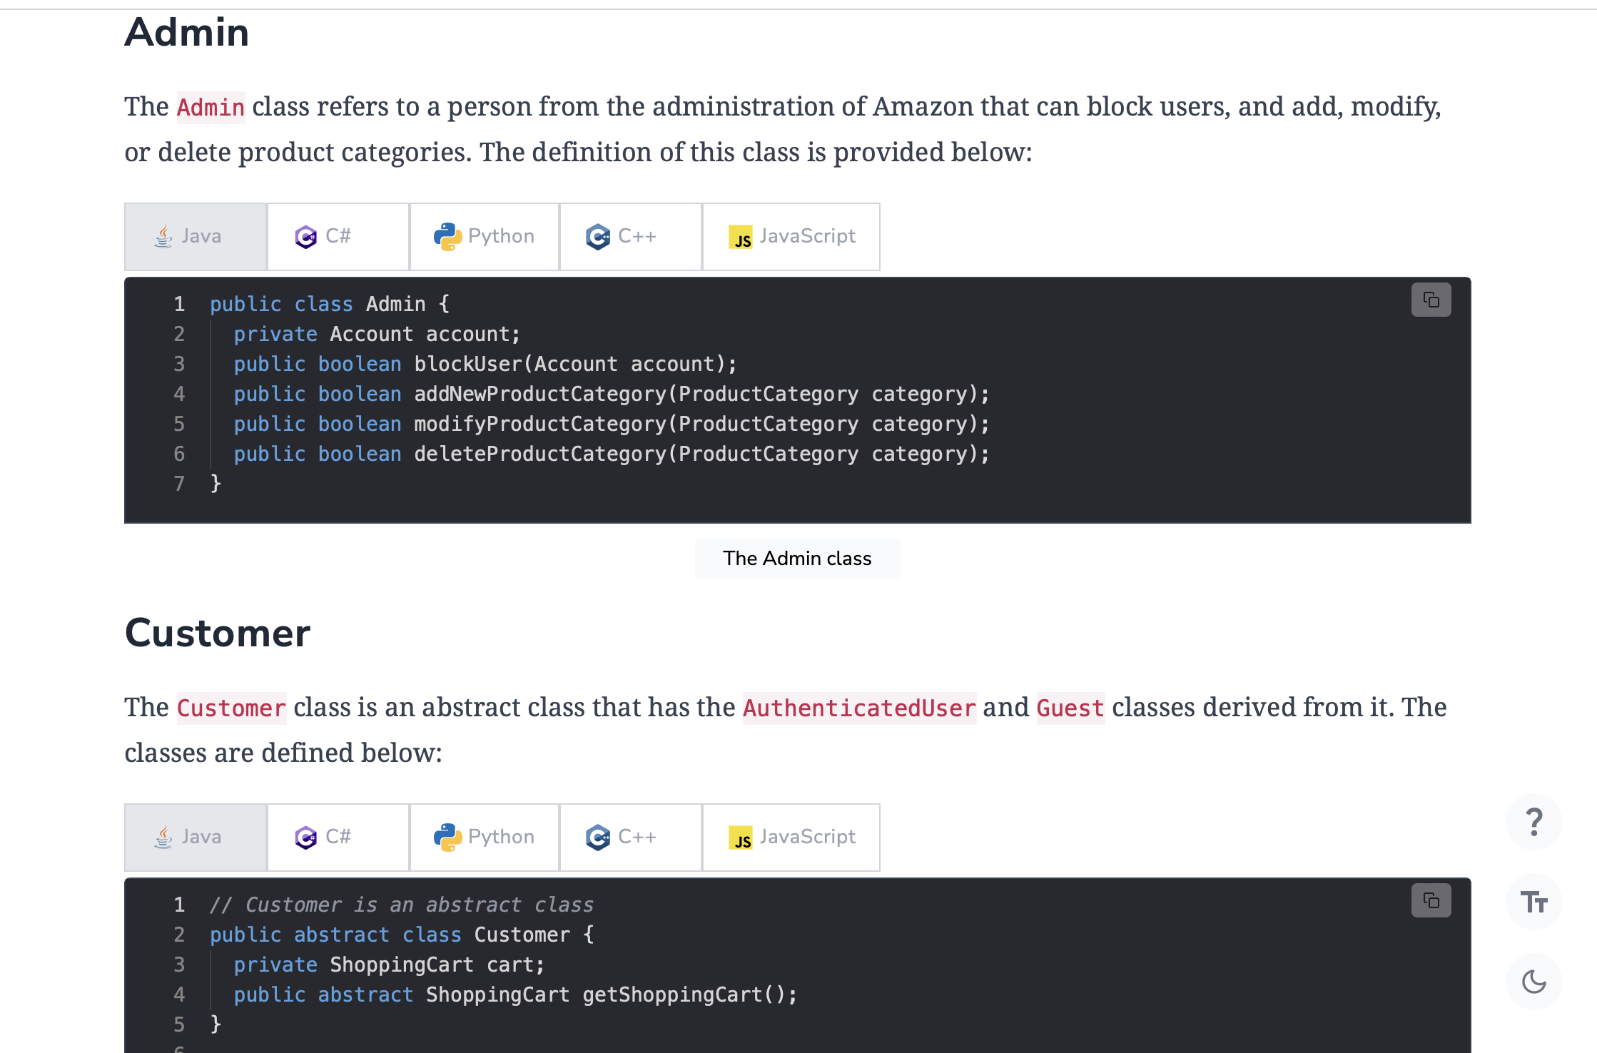

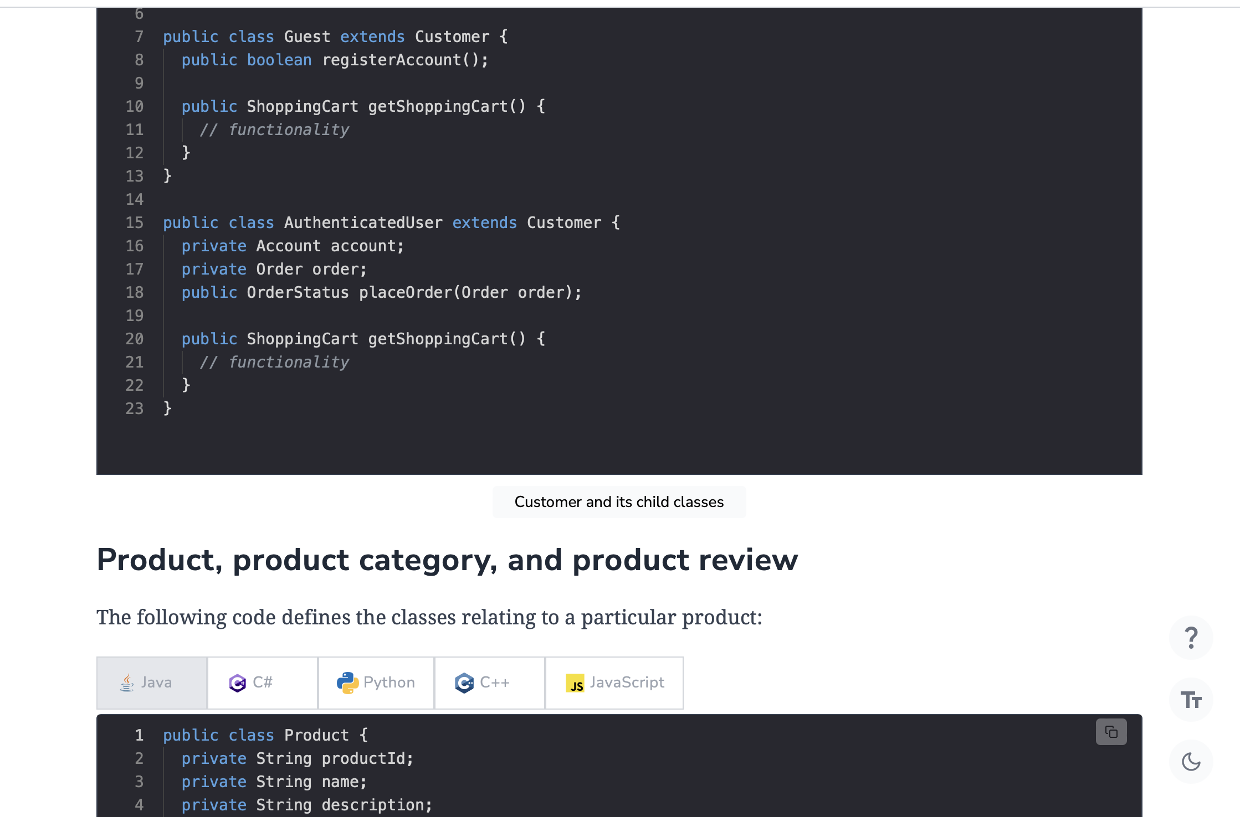

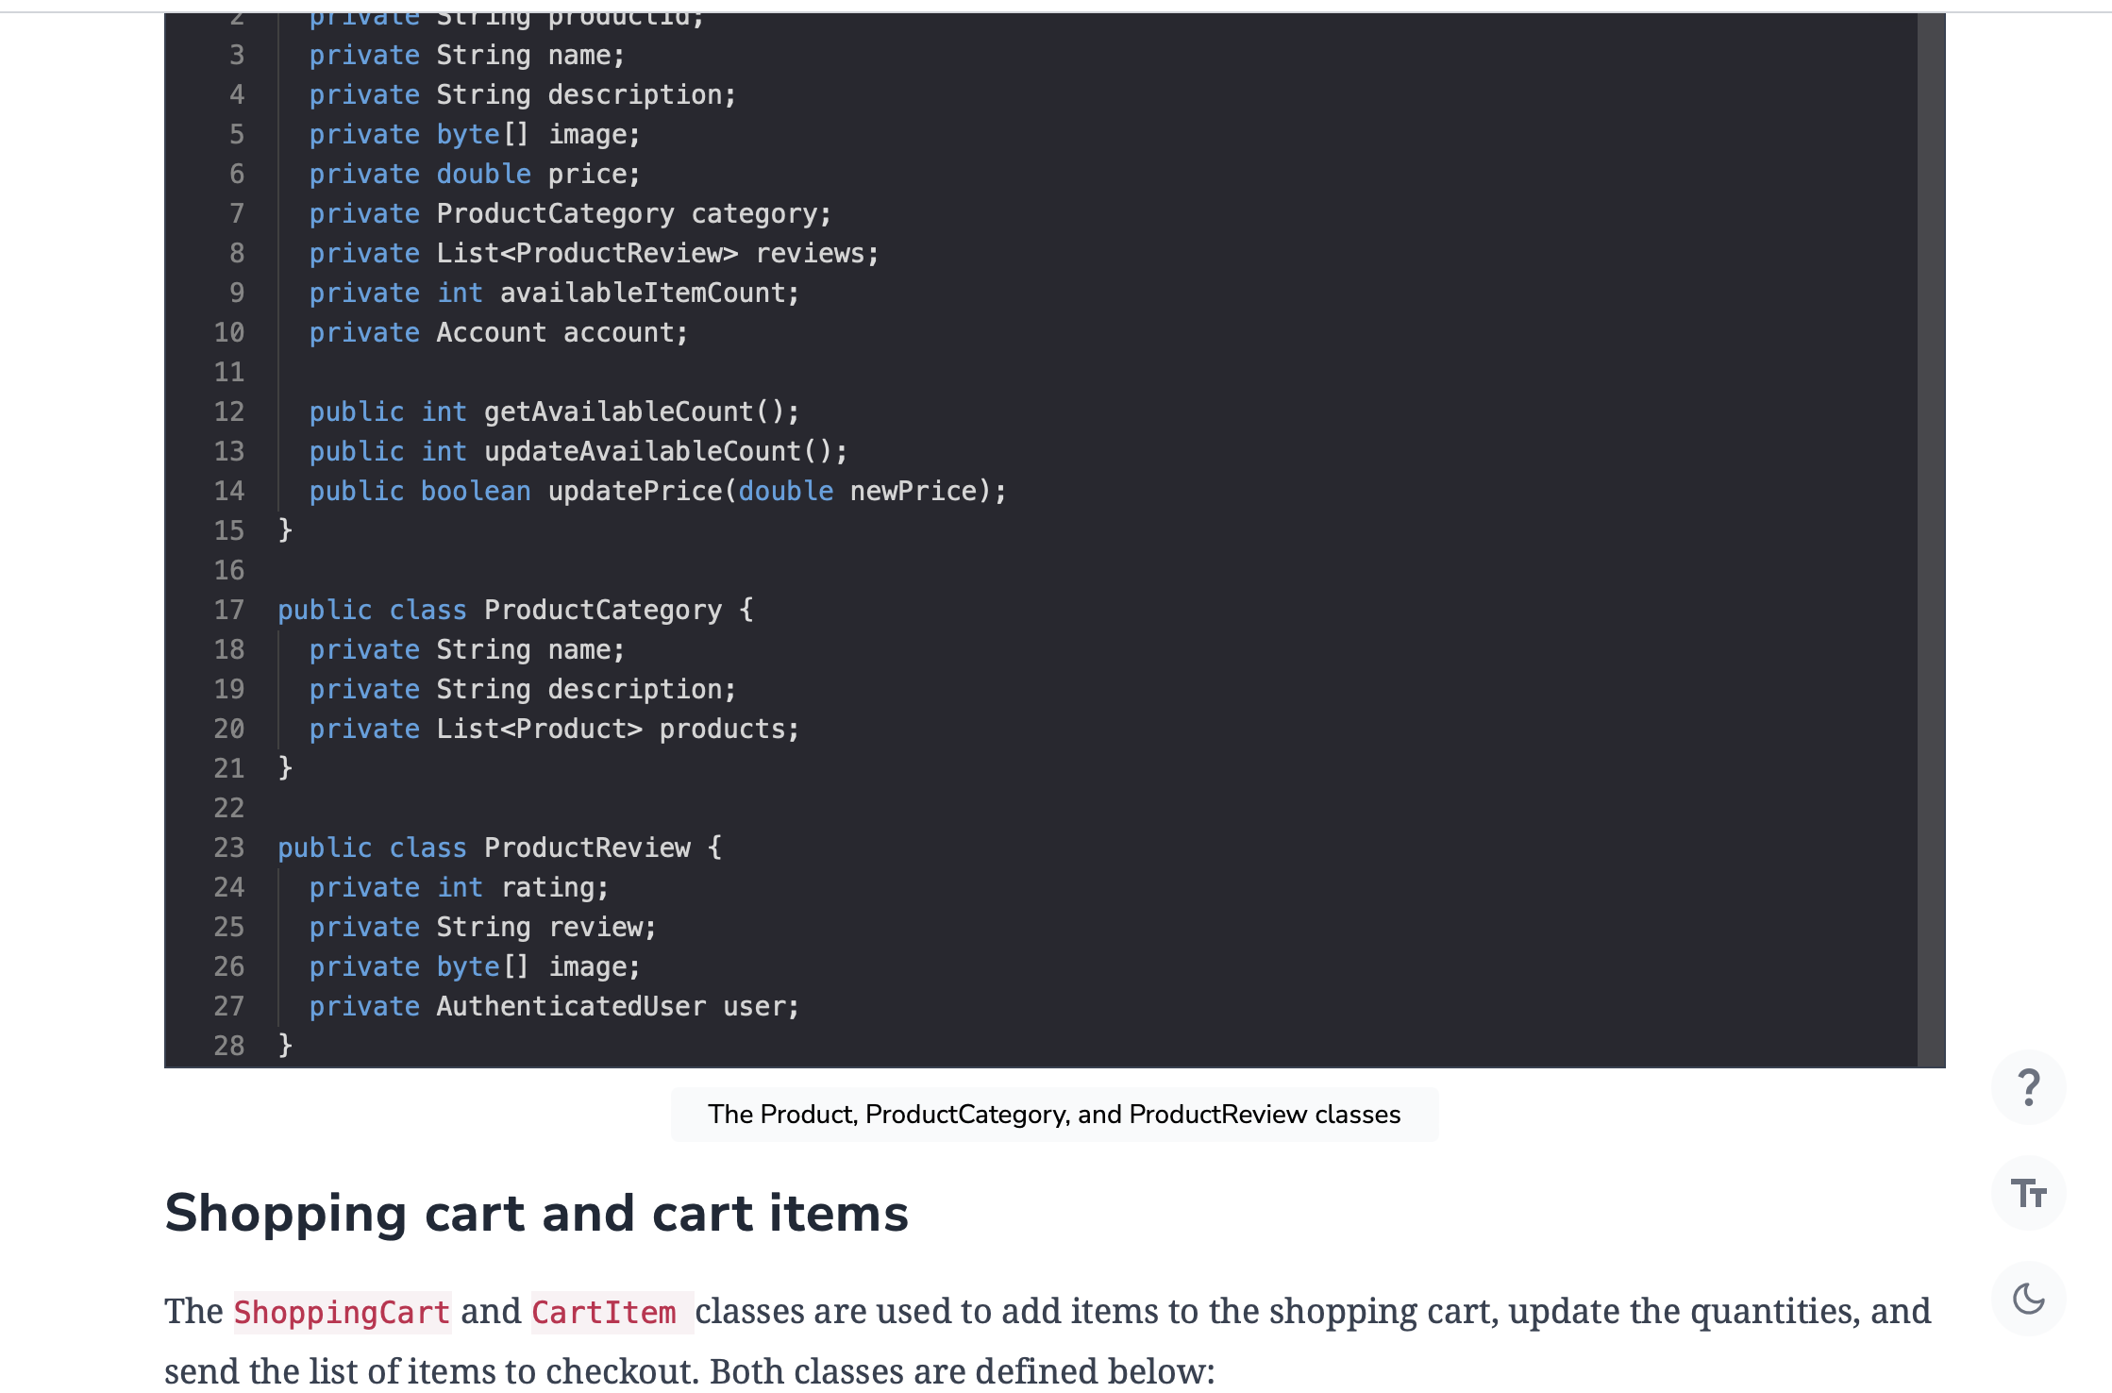

public class CartItem {

private int quantity;

private double price;

public boolean updateQuantity(int quantity);

}

public class ShoppingCart {

private int totalPrice;

private List<Items> items;

public boolean addItem(Item item);

public boolean removeItem(Item item);

public List<Item> getItems();

public boolean checkout();

}

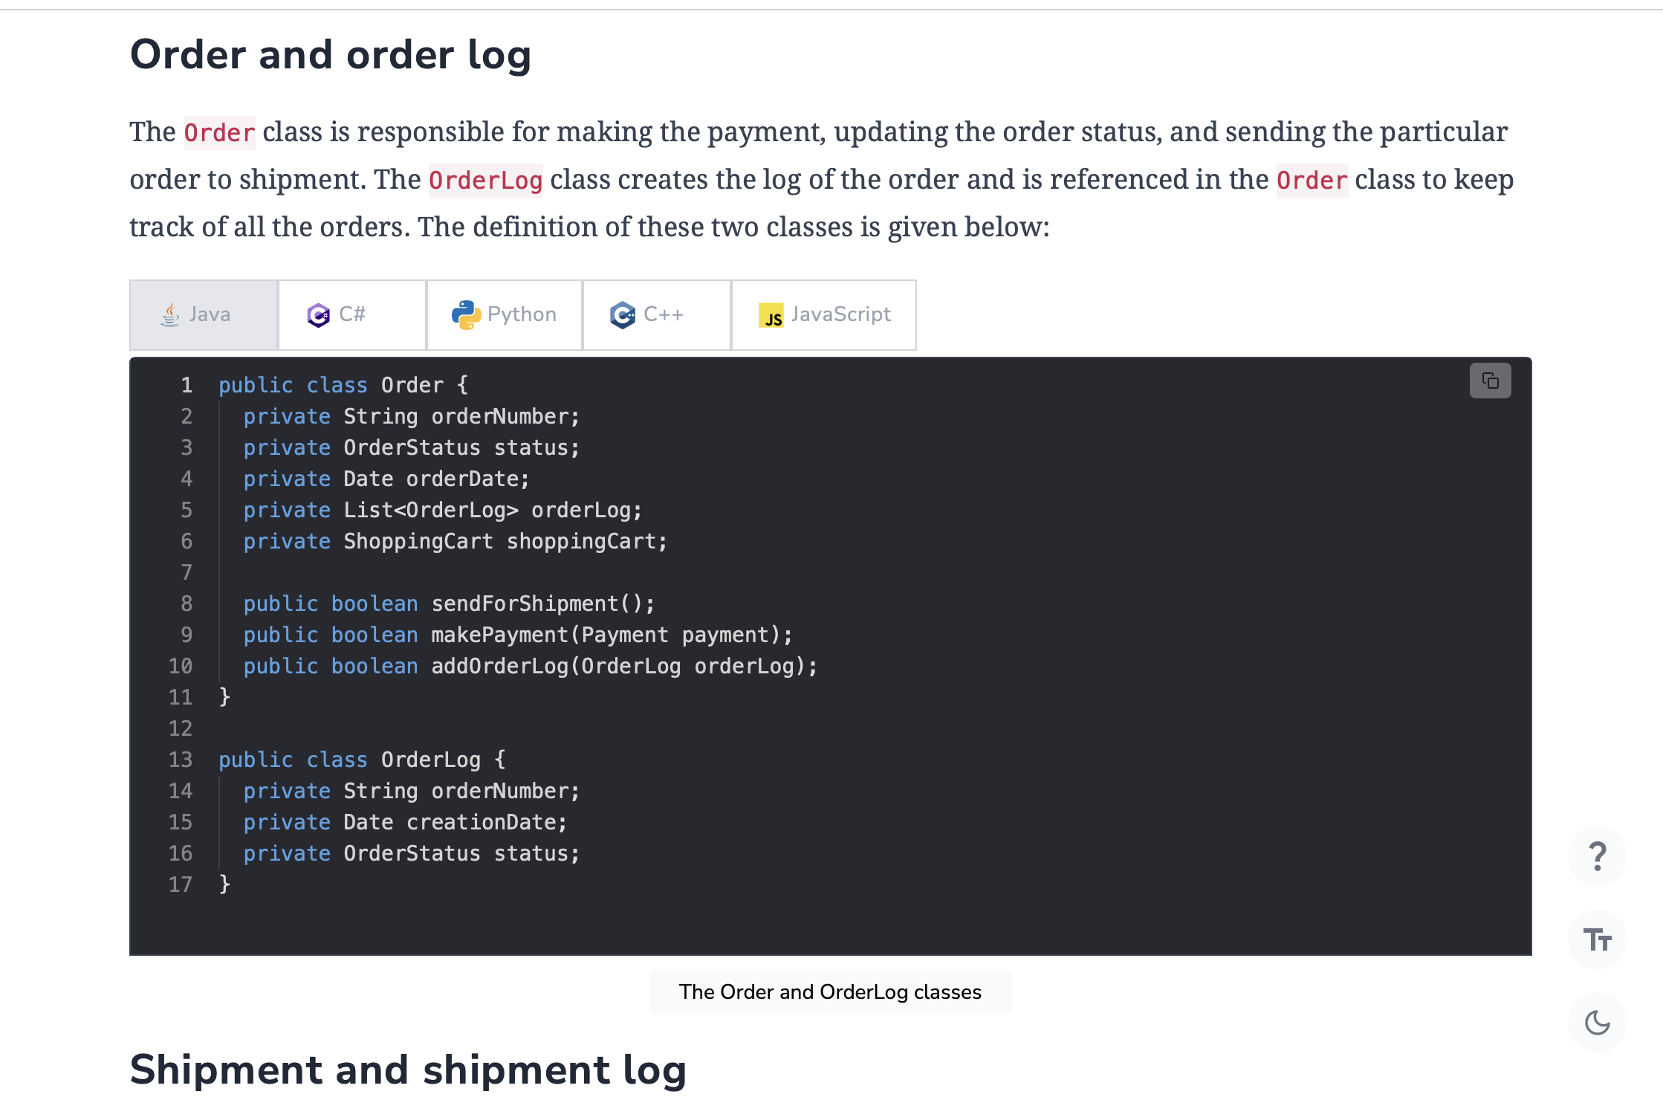

The Shipment class keeps track of all the major details of the order’s dispatch and creates the shipment record using the ShipmentLog class. These classes are defined below:

public class Shipment {

private String shipmentNumber;

private Date shipmentDate;

private Date estimatedArrival;

private String shipmentMethod;

private List<ShipmentLog> shipmentLogs;

public boolean addShipmentLog(ShipmentLog shipmentLog);

}

public class ShipmentLog {

private String shipmentNumber;

private Date creationDate;

private ShipmentStatus status;

}

### Payment

The Payment class is another abstract class with the ElectronicBankTranfer, CreditCard, and Cash classes as its child classes. This takes the PaymentStatus enum to keep track of the payment status. The definition of this class is provided below:

// Payment is an abstract class

public abstract class Payment {

private double amount;

private Date timestamp;

private PaymentStatus status;

public abstract PaymentStatus makePayment();

}

public class CreditCard extends Payment {

private String nameOnCard;

private String cardNumber;

private String billingAddress;

private int code;

public PaymentStatus makePayment() {

// functionality

}

}

public class ElectronicBankTransfer extends Payment {

private String bankName;

private String routingNumber;

private String accountNumber;

private String billingAddress;

public PaymentStatus makePayment() {

// functionality

}

}

public class Cash extends Payment {

private String billingAddress;

public PaymentStatus makePayment() {

// functionality

}

}

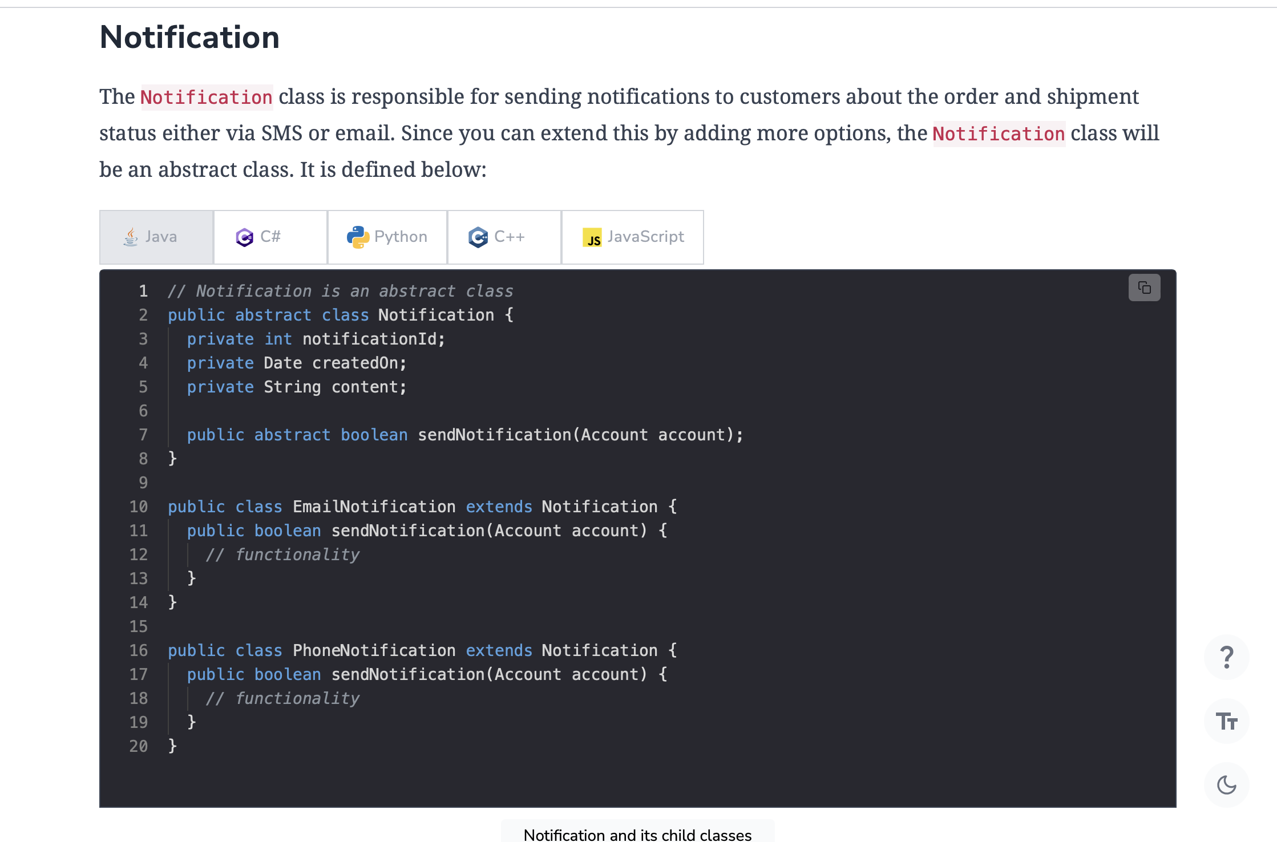

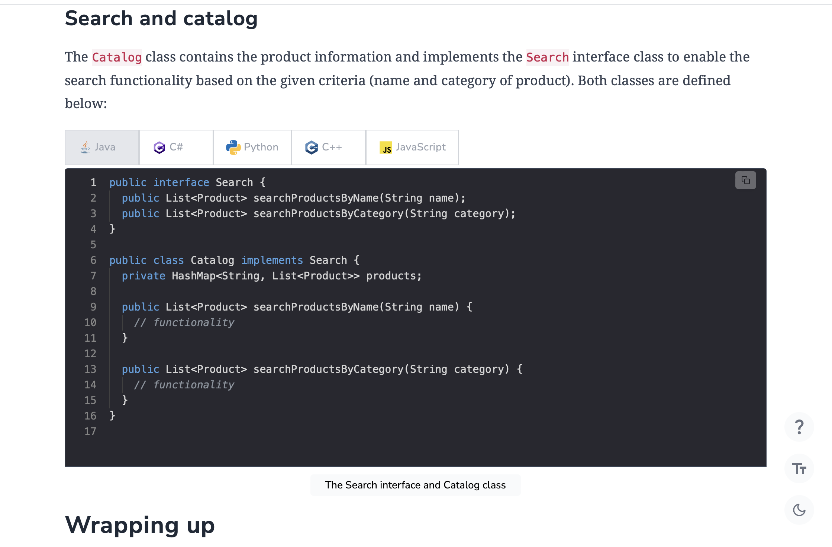

**Wrapping up**

We’ve explored the complete design of Amazon in this chapter. We’ve looked at how Amazon is visualized using various UML diagrams and designed using object-oriented principles and design patterns.

Back